

**AMERICAN INTERNATIONAL UNIVERSITY BANGLADESH-(AIUB)**

**Department of Computer Science & Engineering**

**Course: ADVANCE DATABASE MANAGEMENT SYSTEM**

**SUMMER 2024-2025**

**Section : A**

**Final Term Project**

**Project Report On : MALL MANAGEMENT SYSTEM**

**Supervised By**

**Faculty: JUENA AHMED NOSHIN**

**Submitted By**

**Project Member:**

|  |  |  |
| --- | --- | --- |
| **NAME** | **ID** | **Contribution Percentage** |
| Sumaiya Tasnim | 23-50014-1 | **100%** |

**Submission Deadline : 16-09-2025**

**TABLE OF CONTENTS**

|  |  |  |
| --- | --- | --- |
| **No** | **CHAPTERS** | **PAGES** |
| 1 | Introduction | 01 |
| 2 | Project Proposal | 01-02 |
| 3 | User Interface Planning | 03-09 |
| 4 | Scenerio Description | 09-10 |
| 5 | ER Diagram | 10 |
| 6 | Normalization | 11-17 |
| 7 | Schema Diagram | 18 |
| 8 | Table Creation Using SQL | 19-28 |
| 9 | Data Insertion | 29-35 |
| 10 | Query Writing Using PL/SQL | 37 |
| 11 | Basic PL/SQL | 37-52 |
| 12 | Advance PL/SQL (With Exception Handling) | 52-78 |
| 13 | Relational Algebra | 79 |
| 14 | User Interface Design To Code Implementation | 80- |
| 15 | Oracle 10g Database Connection Process |  |
| 16 | Conclusion |  |

**“Mall Management System”**

**1.Introduction**  
The **Mall Management System** is a database-driven application designed to streamline the daily operations of a shopping mall. From managing shops and shopkeepers to handling customer data, inventory, billing, and maintenance records, the system provides a centralized and structured way to organize all essential information. It helps reduce manual errors, saves time, and ensures that operations run smoothly and efficiently.Malls typically generate and handle large amounts of data every day. Without a proper system in place, this can quickly become overwhelming. The Mall Management System addresses this challenge by offering an easy-to-use interface backed by a well-designed database that ensures secure data storage, quick access, and consistent updates.This project highlights the practical use of sound database design principles and demonstrates how technology can simplify complex real-world processes, improve coordination, and support better management decisions.

**2.Project Proposal**

### ****Objectives****

· To create a system that helps manage mall activities in an organized way.

· To reduce manual work and avoid mistakes in storing and updating data.

· To keep all shop, customer, and inventory details in one place for easy access.

· To make billing and reporting faster and more accurate.

· To support mall staff in managing shops, customers, and stock more smoothly.

### ****Problem Statement****

Managing a shopping mall involves handling a lot of information like shop details, customer records, inventory, and billing. Doing all of this manually can take a lot of time and may lead to mistakes or missing data. It also becomes hard to find or update information quickly. Because of this, mall operations can slow down and become less efficient. A proper system is needed to store all data in one place, reduce manual work, and help the mall run more smoothly.

### ****Methodology****

We will develop the project through a clear step-by-step approach focused on database design and implementation:

**Requirement Analysis:** We will study the mall management needs to identify what data should be stored and managed.

**Database Design:** We will create an Entity-Relationship (ER) diagram to organize data and define relationships between entities such as shops, customers, and inventory.

**Database Implementation:** We will build the database using Oracle 10g, creating tables, keys, and constraints to maintain data integrity.

**Query Development:** We will write SQL queries, stored procedures, and triggers to handle data operations like inserting, updating, deleting, and generating reports.

**Documentation:** We will prepare clear documentation detailing the database schema, queries, and usage instructions.

### ****System Features****

1. Add, update, and delete shop details easily.
2. Manage shopkeeper and employee information.
3. Store and access customer details and purchase history.
4. Keep track of inventory and notify when stock is low.
5. Generate bills and invoices automatically.
6. Create reports on sales, inventory, and maintenance.
7. **Handle maintenance requests and track their status.**

### ****Expected Outcome****

We expect to develop a reliable and efficient database system that centralizes all mall management data in one place. This system will allow us to store, update, and retrieve information quickly and accurately using SQL operations. By automating tasks like billing, inventory tracking, and report generation, we will reduce manual errors and save time. The final outcome will be a well-organized database that supports mall administrators and customers in managing daily operations smoothly and effectively.

**3.User Interface Planning**

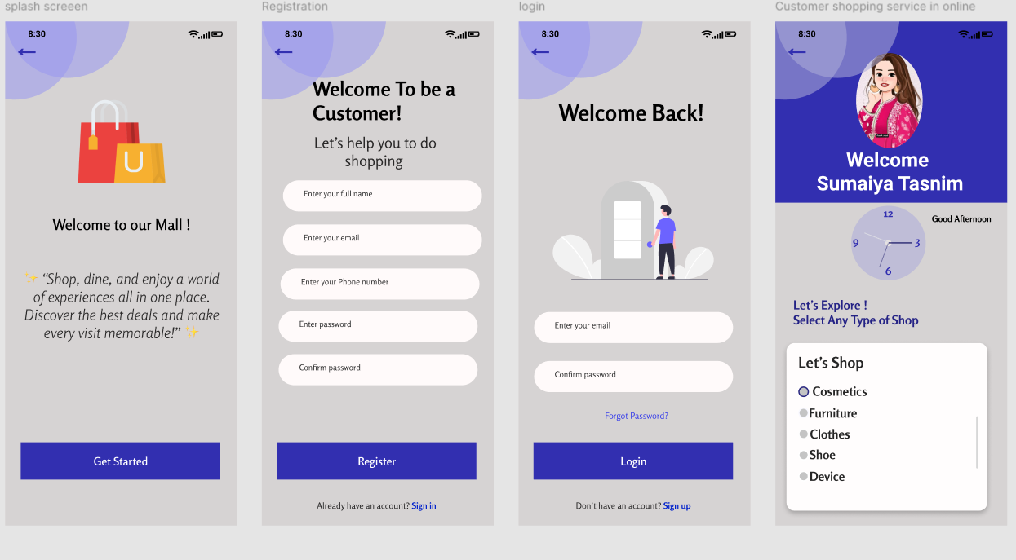

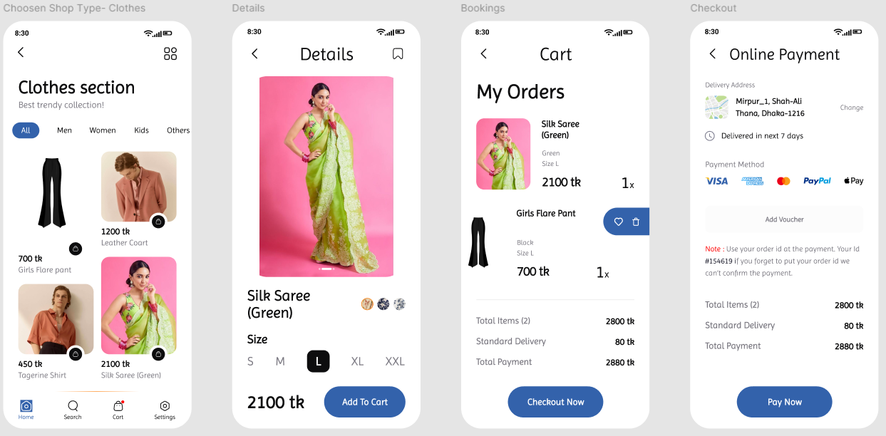

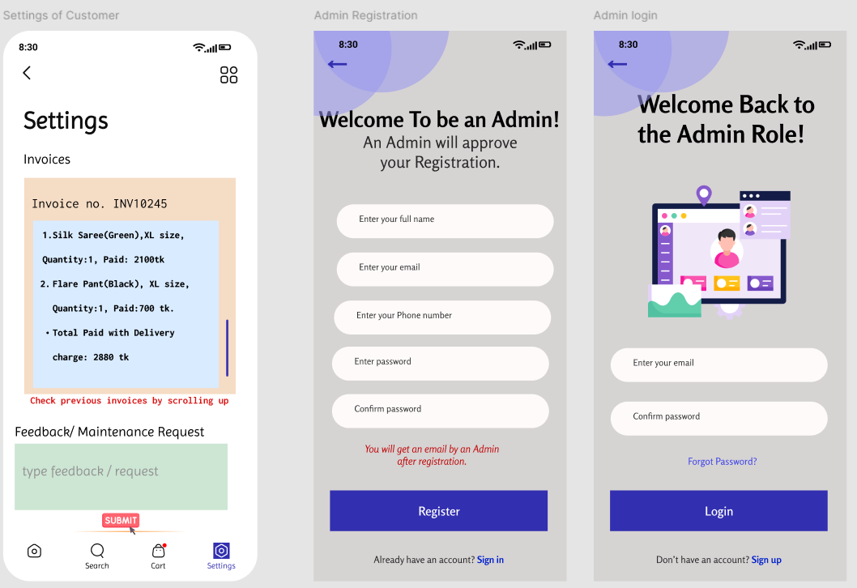

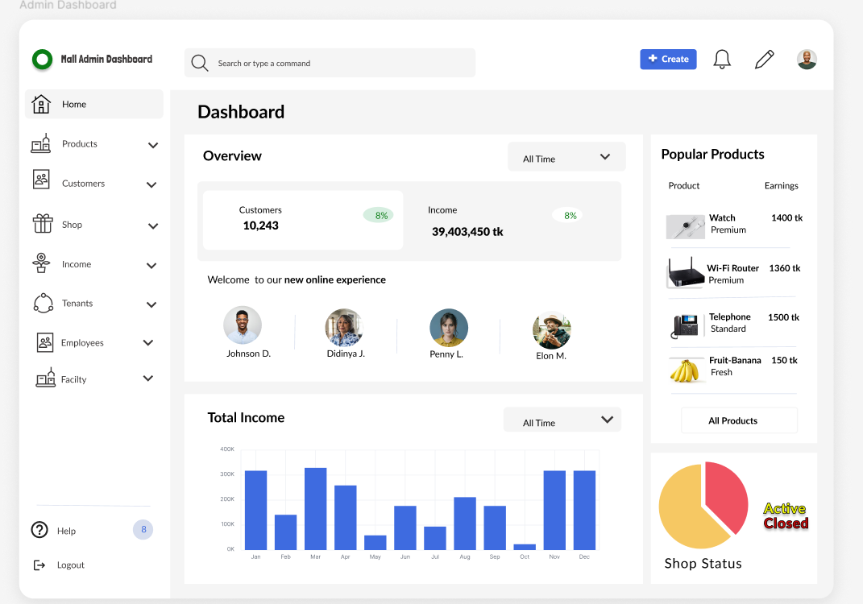

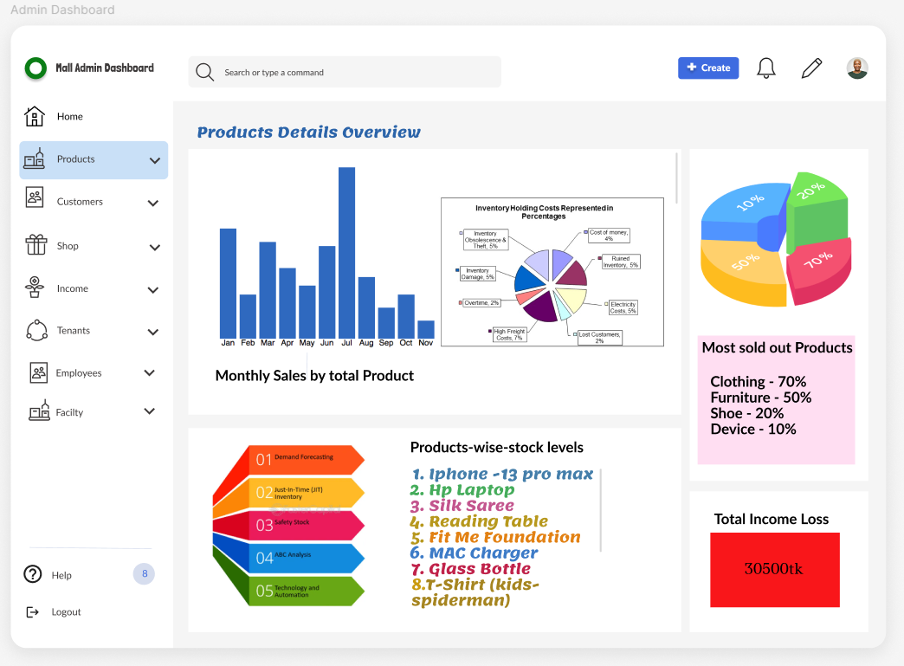

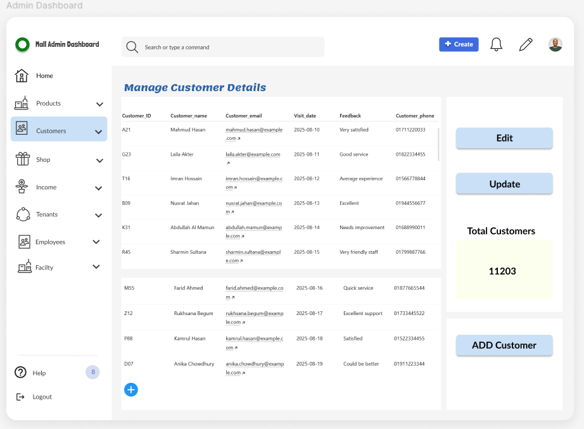

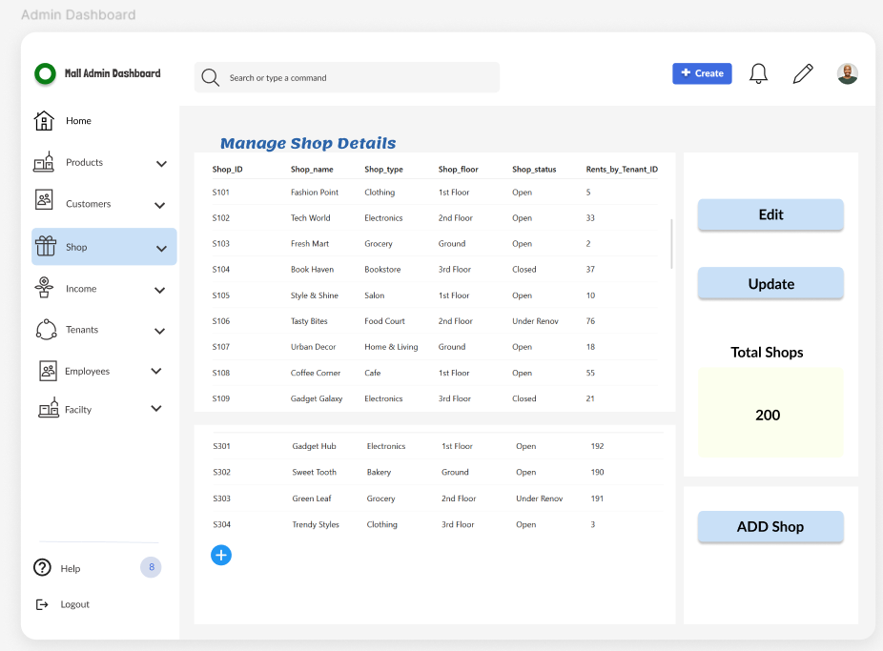

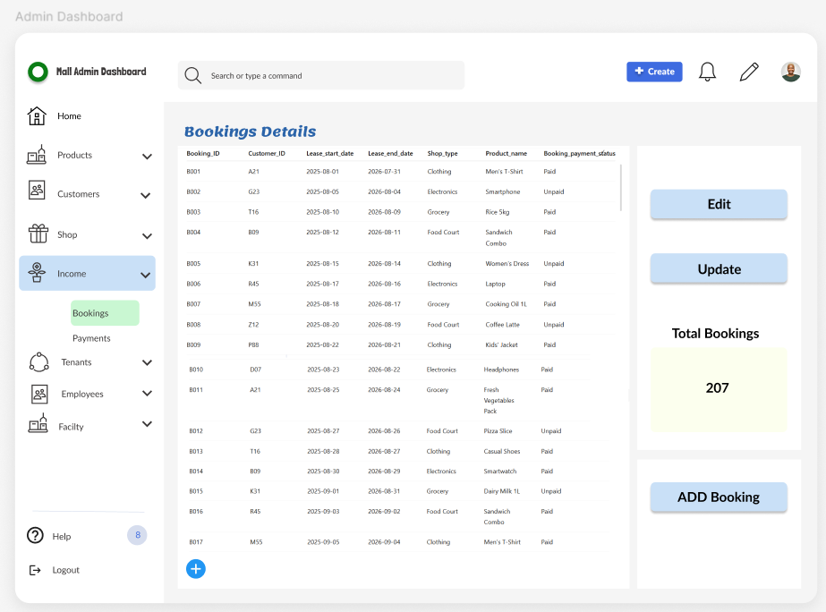

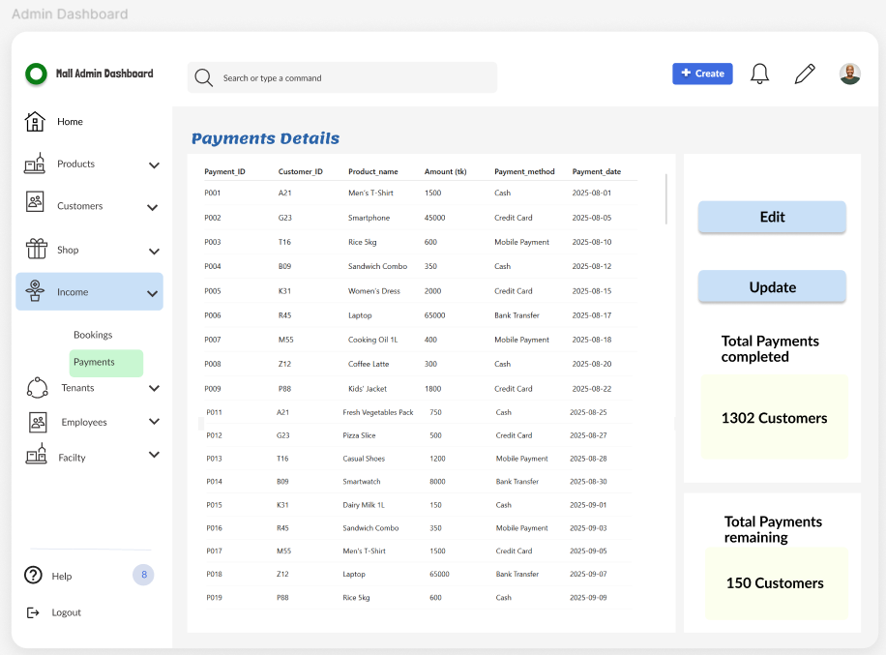

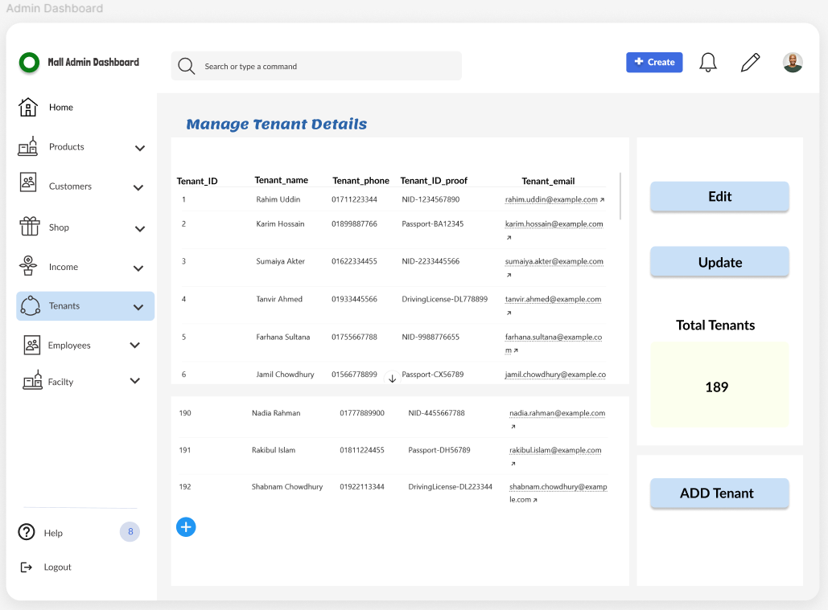

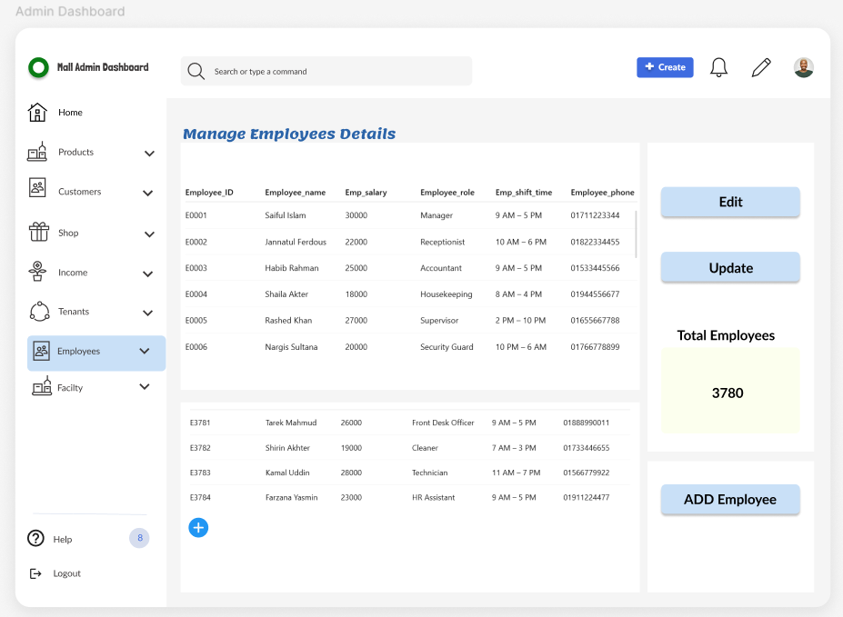

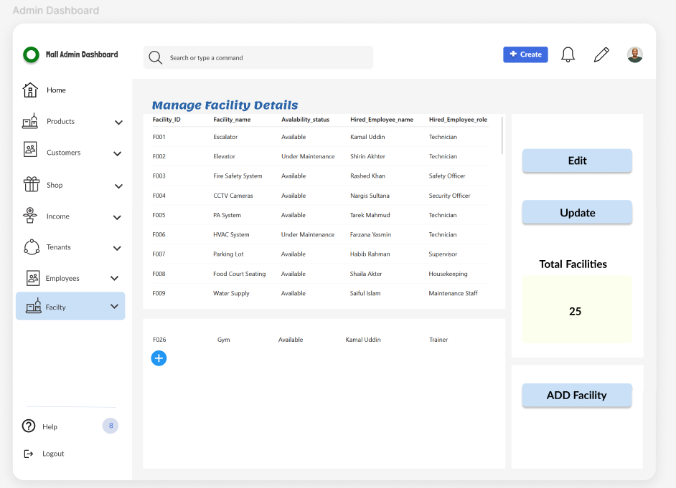

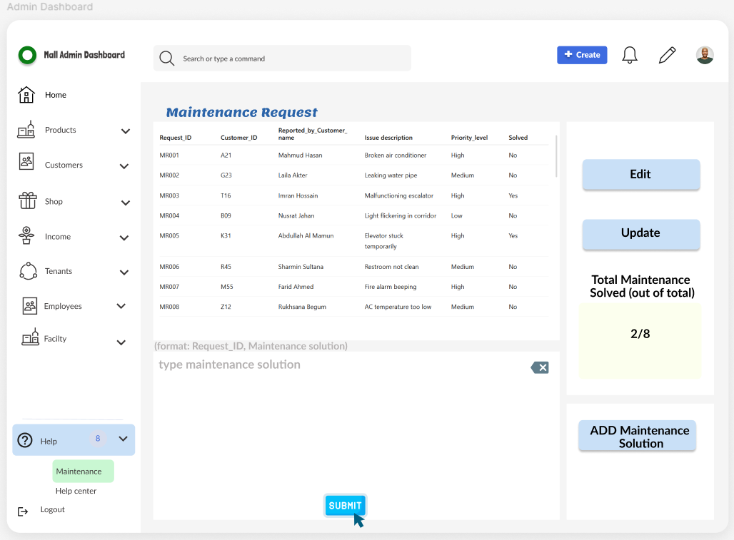

**4.Scenario Description**

In a Mall Management System, one **administrator** manages many shops, facilities and supervises employees. Each administrator has a unique identification number, name, phone number, and email. A **shop** has a unique identification number, name, type, floor, and current status. Each shop is rented by exactly one tenant. One **tenant** may rent one or more shops. A tenant is defined by a unique tenant ID, name, phone number, email and ID proof.A shop must have a **booking** record. One shop can have one or more bookings, but a booking is related to one shop only. A booking is defined by a booking ID, rent, lease start and end dates, and payment status. A **payment** is made by a tenant for a shop. One payment is linked to exactly one tenant and one shop. Payment is identified by a unique payment ID, amount, date and method.A shop can have many **customers**. Each customer has a unique identification number, name, phone number, email, visit date, and feedback. A customer can have more than one phone number and email.Each **employee** works under the administrator and may include cleaners, support staff, and other roles. An employee has a unique identification number, name, role, shift time, salary and phone number. The **mall** provides various **facilities** like elevators, parking, and restrooms. Each facility has a unique identification number, name, and availability status. Facilities may be associated with one or more **maintenance requests**. A maintenance request is defined by a request ID, facility ID, issue description, reported by, priority level. **Security guards** are also part of the employee group, but are maintained separately. Each security guard has a unique identification number, name, shift time, phone number and salary. The system offers a centralized platform for efficient administration, ensuring that all operations—from shop allocation to facility monitoring—run seamlessly to enhance service quality and overall mall management.

**5.ER Diagram**

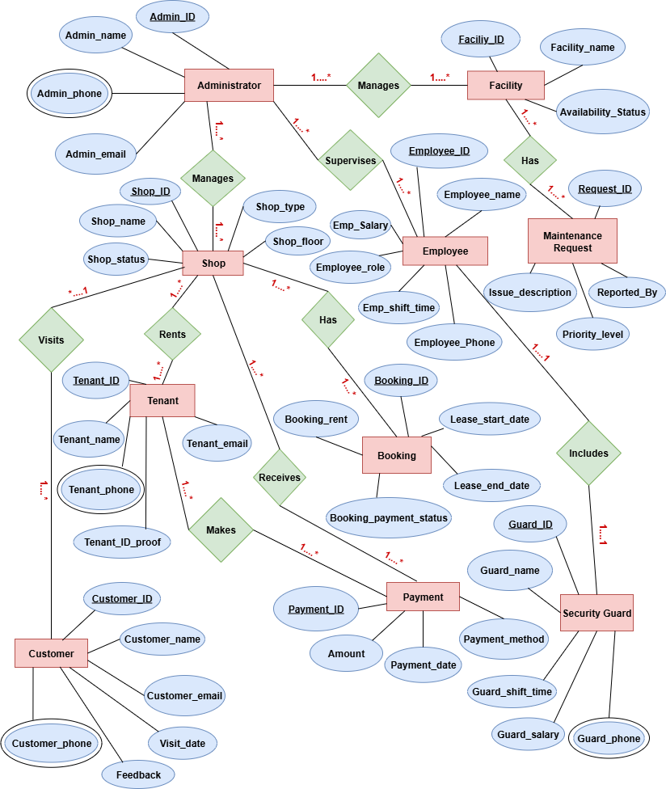

**6.Normalization**

**Manages (Administrator-Shop)**

**UNF**

Manages (Admin_ID, Admin_name, Admin_phone, Admin_email, Shop_ID, Shop_name, Shop_status, Shop_type, Shop_floor)

**1NF**

Admin_phone is a multi valued attribute.

1. Admin_ID, Admin_name, Admin_phone, Admin_email, Shop_ID, Shop_name, Shop_status, Shop_type, Shop_floor

**2NF**

1. Admin_ID, Admin_name, Admin_phone, Admin_email
2. Shop_ID, Shop_name, Shop_status, Shop_type, Shop_floor

**3NF**

There is no transitive dependency. Relation already in 3NF.

1. Admin_ID, Admin_name, Admin_phone, Admin_email
2. Shop_ID, Shop_name, Shop_status, Shop_type, Shop_floor

**Table Creation**

1. Admin_ID, Admin_name, Admin_phone, Admin_email
2. Shop_ID, Shop_name, Shop_status, Shop_type, Shop_floor, **A_ID**

### ****Manages (Administrator-Facility)****

****UNF****  
Manages (Admin_ID, Admin_name, Admin_phone, Admin_email, Facility_ID, Facility_name, Availability_Status)

**1NF**  
Admin_phone is a multivalued attribute.

1. Admin_ID, Admin_name, Admin_phone, Admin_email, Facility_ID, Facility_name, Availability_Status

**2NF**

1. Admin_ID, Admin_name, Admin_phone, Admin_email
2. Facility_ID, Facility_name, Availability_Status

**3NF**  
There is no transitive dependency. Relation already in 3NF.

1. Admin_ID, Admin_name, Admin_phone, Admin_email
2. Facility_ID, Facility_name, Availability_Status

**Table Creation**

1. Admin_ID, Admin_name, Admin_phone, Admin_email
2. Facility_ID, Facility_name, Availability_Status, **A_ID**

### ****Supervises (Administrator-Employee)****

**UNF**  
Supervises (Admin_ID, Admin_name, Admin_phone, Admin_email, Employee_ID, Employee_name, Emp_salary, Employee_role, Employee_phone, Emp_shift_time)

**1NF**  
Admin_phone and Employee_phone are multi valued attributes.

1 Admin_ID, Admin_name, Admin_phone, Admin_email

2.Employee_ID, Employee_name, Emp_salary, Employee_role, Employee_phone, Emp_shift_time

**2NF**  
1. Admin_ID, Admin_name, Admin_phone, Admin_email

2.Employee_ID, Employee_name, Emp_salary, Employee_role, Employee_phone, Emp_shift_time

**3NF**  
There is no transitive dependency. Relation already in 3NF.

1. Admin_ID, Admin_name, Admin_phone, Admin_email
2. Employee_ID, Employee_name, Emp_salary, Employee_role, Employee_phone, Emp_shift_time

**Table Creation**

1. Admin_ID, Admin_name, Admin_phone, Admin_email
2. Employee_ID, Employee_name, Emp_salary, Employee_role, Employee_phone, Emp_shift_time, **A_ID**

### ****Has (Facility - Maintenance Request)****

**UNF**  
Has (Facility_ID, Facility_name, Availability_Status, Request_ID, Issue_description, Reported_by, Priority_level)

**1NF**  
There is no multi valued attribute. Relation already in 1NF.

1. Facility_ID, Facility_name, Availability_Status
2. Request_ID, Issue_description, Reported_by, Priority_level

**2NF**

1. Facility_ID, Facility_name, Availability_Status
2. Request_ID, Issue_description, Reported_by, Priority_level

**3NF**  
There is no transitive dependency. Relation already in 3NF.

1. Facility_ID, Facility_name, Availability_Status
2. Request_ID, Issue_description, Reported_by, Priority_level

**Table Creation**

1. Facility_ID, Facility_name, Availability_Status
2. Request_ID, Issue_description, Reported_by, Priority_level, **F_ID**

### ****Rents (Tenant-Shop)****

**UNF**  
Rents (Tenant_ID, Tenant_name, Tenant_email, Tenant_phone, Tenant_ID_proof, Shop_ID, Shop_name, Shop_status, Shop_type, Shop_floor)

**1NF**  
Tenant_phone is multi valued attribute.

1. Tenant_ID, Tenant_name, Tenant_email, Tenant_phone, Tenant_ID_proof
2. Shop_ID, Shop_name, Shop_status, Shop_type, Shop_floor

**2NF**

1. Tenant_ID, Tenant_name, Tenant_email, Tenant_phone, Tenant_ID_proof
2. Shop_ID, Shop_name, Shop_status, Shop_type, Shop_floor

**3NF**  
There is no transitive dependency. Relation already in 3NF.

1. Tenant_ID, Tenant_name, Tenant_email, Tenant_phone, Tenant_ID_proof
2. Shop_ID, Shop_name, Shop_status, Shop_type, Shop_floor

**Table Creation**

1. Tenant_ID, Tenant_name, Tenant_email, Tenant_phone, Tenant_ID_proof
2. Shop_ID, Shop_name, Shop_status, Shop_type, Shop_floor, **T_ID**

### ****Makes (Tenant - Payment)****

**UNF**  
Makes (Tenant_ID, Tenant_name, Tenant_phone, Tenant_email, Tenant_ID_proof, Payment_ID, Amount, Payment_date, Payment_method)

**1NF**  
Tenant_phone is a multi valued attribute.

1. Tenant_ID, Tenant_name, Tenant_phone, Tenant_email, Tenant_ID_proof, Payment_ID, Amount, Payment_date, Payment_method

**2NF**  
1. Tenant_ID, Tenant_name, Tenant_phone, Tenant_email, Tenant_ID_proof

1. Payment_ID, Amount, Payment_date, Payment_method

**3NF**  
There is no transitive dependency. Relation already in 3NF.

1. Tenant_ID, Tenant_name, Tenant_phone, Tenant_email, Tenant_ID_proof
2. Payment_ID, Amount, Payment_date, Payment_method

**Table Creation**

1. Tenant_ID, Tenant_name, Tenant_phone, Tenant_email, Tenant_ID_proof
2. Payment_ID, Amount, Payment_date, Payment_method, **T_ID**

### ****Receives (Shop - Payment)****

**UNF**  
Receives (Shop_ID, Shop_name, Shop_status, Shop_type, Shop_floor, Payment_ID, Amount, Payment_date, Payment_method)

**1NF**  
There is no multivalued attribute. Relation is already in 1NF.

1. Shop_ID, Shop_name, Shop_status, Shop_type, Shop_floor, Payment_ID, Amount, Payment_date, Payment_method

**2NF**  
1. Shop_ID, Shop_name, Shop_status, Shop_type, Shop_floor

1. Payment_ID, Amount, Payment_date, Payment_method

**3NF**  
There is no transitive dependency. Relation already in 3NF.

1. Shop_ID, Shop_name, Shop_status, Shop_type, Shop_floor

2.Payment_ID, Amount, Payment_date, Payment_method

**Table Creation**

1. Shop_ID, Shop_name, Shop_status, Shop_type, Shop_floor
2. Payment_ID, Amount, Payment_date, Payment_method, **S_ID**

### ****Has (Shop - Booking)****

**UNF**  
Has (Shop_ID, Shop_name, Shop_status, Shop_type, Shop_floor, Booking_ID, Booking_rent, Lease_start_date, Lease_end_date, Booking_payment_status)

**1NF**  
There is no multivalued attribute. Relation is already in 1NF.

1. Shop_ID, Shop_name, Shop_status, Shop_type, Shop_floor, Booking_ID, Booking_rent, Lease_start_date, Lease_end_date, Booking_payment_status

**2NF**

1.Shop_ID, Shop_name, Shop_status, Shop_type, Shop_floor

2. Booking_ID, Booking_rent, Lease_start_date, Lease_end_date, Booking_payment_status

**3NF**  
There is no transitive dependency. Relation already in 3NF.

1. Shop_ID, Shop_name, Shop_status, Shop_type, Shop_floor
2. Booking_ID, Booking_rent, Lease_start_date, Lease_end_date, Booking_payment_status

**Table Creation**

1. Shop_ID, Shop_name, Shop_status, Shop_type, Shop_floor
2. Booking_ID, Booking_rent, Lease_start_date, Lease_end_date, Booking_payment_status, **S_ID**

### ****Visits (Shop - Customer)****

**UNF**  
Visits (Shop_ID, Shop_name, Shop_status, Shop_type, Shop_floor, Customer_ID, Customer_name, Customer_email, Customer_phone, Visit_date, Feedback)

**1NF**  
Customer_phone is a multi valued attribute.

1. Shop_ID, Shop_name, Shop_status, Shop_type, Shop_floor, Customer_ID, Customer_name, Customer_email, Customer_phone, Visit_date, Feedback

**2NF**  
1. Shop_ID, Shop_name, Shop_status, Shop_type, Shop_floor

1. Customer_ID, Customer_name, Customer_email, Customer_phone, Visit_date, Feedback

**3NF**  
There is no transitive dependency. Relation already in 3NF.

1. Shop_ID, Shop_name, Shop_status, Shop_type, Shop_floor
2. Customer_ID, Customer_name, Customer_email, Customer_phone, Visit_date, Feedback

**Table Creation**

1. Shop_ID, Shop_name, Shop_status, Shop_type, Shop_floor
2. Customer_ID, Customer_name, Customer_email, Customer_phone, Visit_date, Feedback, **S_ID**

### ****Includes (Employee – Security Guard)****

**UNF**  
Includes (Employee_ID, Employee_name, Emp_salary, Employee_role, Emp_shift_time, Employee_phone, Guard_ID, Guard_name, Guard_phone, Guard_shift_time, Guard_salary)

**1NF**  
Employee_phone and Guard_phone are multi valued attributes.

1. Employee_ID, Employee_name, Emp_salary, Employee_role, Emp_shift_time, Employee_phone, Guard_ID, Guard_name, Guard_phone, Guard_shift_time, Guard_salary

**2NF**

1. Employee_ID, Employee_name, Emp_salary, Employee_role, Emp_shift_time, Employee_phone
2. Guard_ID, Guard_name, Guard_phone, Guard_shift_time, Guard_salary

**3NF**  
There is no transitive dependency. Relation already in 3NF.

1. Employee_ID, Employee_name, Emp_salary, Employee_role, Emp_shift_time, Employee_phone
2. Guard_ID, Guard_name, Guard_phone, Guard_shift_time, Guard_salary, Employee_ID

**Table Creation**

1. Employee_ID, Employee_name, Emp_salary, Employee_role, Emp_shift_time, Employee_phone
2. Guard_ID, Guard_name, Guard_phone, Guard_shift_time, Guard_salary, **E_ID**

**Temporary Tables**

1. Admin_ID, Admin_name, Admin_phone, Admin_email
2. Shop_ID, Shop_name, Shop_status, Shop_type, Shop_floor, **A_ID**
3. ~~Admin_ID, Admin_name, Admin_phone, Admin_email~~
4. Facility_ID, Facility_name, Availability_Status, **A_ID**
5. ~~Admin_ID, Admin_name, Admin_phone, Admin_email~~
6. Employee_ID, Employee_name, Emp_salary, Employee_role, Employee_phone, Emp_shift_time, **A_ID**
7. ~~Facility_ID, Facility_name, Availability_Status~~
8. Request_ID, Issue_description, Reported_by, Priority_level, **F_ID**
9. Tenant_ID, Tenant_name, Tenant_email, Tenant_phone, Tenant_ID_proof
10. ~~Shop_ID, Shop_name, Shop_status, Shop_type, Shop_floor,~~ **~~T_ID~~**
11. ~~Tenant_ID, Tenant_name, Tenant_phone, Tenant_email, Tenant_ID_proof~~
12. Payment_ID, Amount, Payment_date, Payment_method, **T_ID**
13. ~~Shop_ID, Shop_name, Shop_status, Shop_type, Shop_floor~~
14. ~~Payment_ID, Amount, Payment_date, Payment_method,~~ **~~S_ID~~**
15. ~~Shop_ID, Shop_name, Shop_status, Shop_type, Shop_floor~~
16. Booking_ID, Booking_rent, Lease_start_date, Lease_end_date, Booking_payment_status, **S_ID**
17. ~~Shop_ID, Shop_name, Shop_status, Shop_type, Shop_floor~~
18. Customer_ID, Customer_name, Customer_email, Customer_phone, Visit_date, Feedback, **S_ID**
19. ~~Employee_ID, Employee_name, Emp_salary, Employee_role, Emp_shift_time, Employee_phone~~
20. Guard_ID, Guard_name, Guard_phone, Guard_shift_time, Guard_salary, **E_ID**

**Final Tables**

1.Admin_ID, Admin_name, Admin_phone, Admin_email

2. Shop_ID, Shop_name, Shop_status, Shop_type, Shop_floor, **A_ID**

3. Facility_ID, Facility_name, Availability_Status, **A_ID**

4. Employee_ID, Employee_name, Emp_salary, Employee_role, Employee_phone, Emp_shift_time, **A_ID**

5. Request_ID, Issue_description, Reported_by, Priority_level, **F_ID**

6. Tenant_ID, Tenant_name, Tenant_email, Tenant_phone, Tenant_ID_proof

7. Payment_ID, Amount, Payment_date, Payment_method, **T_ID**

8. Booking_ID, Booking_rent, Lease_start_date, Lease_end_date, Booking_payment_status, **S_ID**

9. Customer_ID, Customer_name, Customer_email, Customer_phone, Visit_date, Feedback, **S_ID**

10. Guard_ID, Guard_name, Guard_phone, Guard_shift_time, Guard_salary, **E_ID**

**7.Schema Diagram**

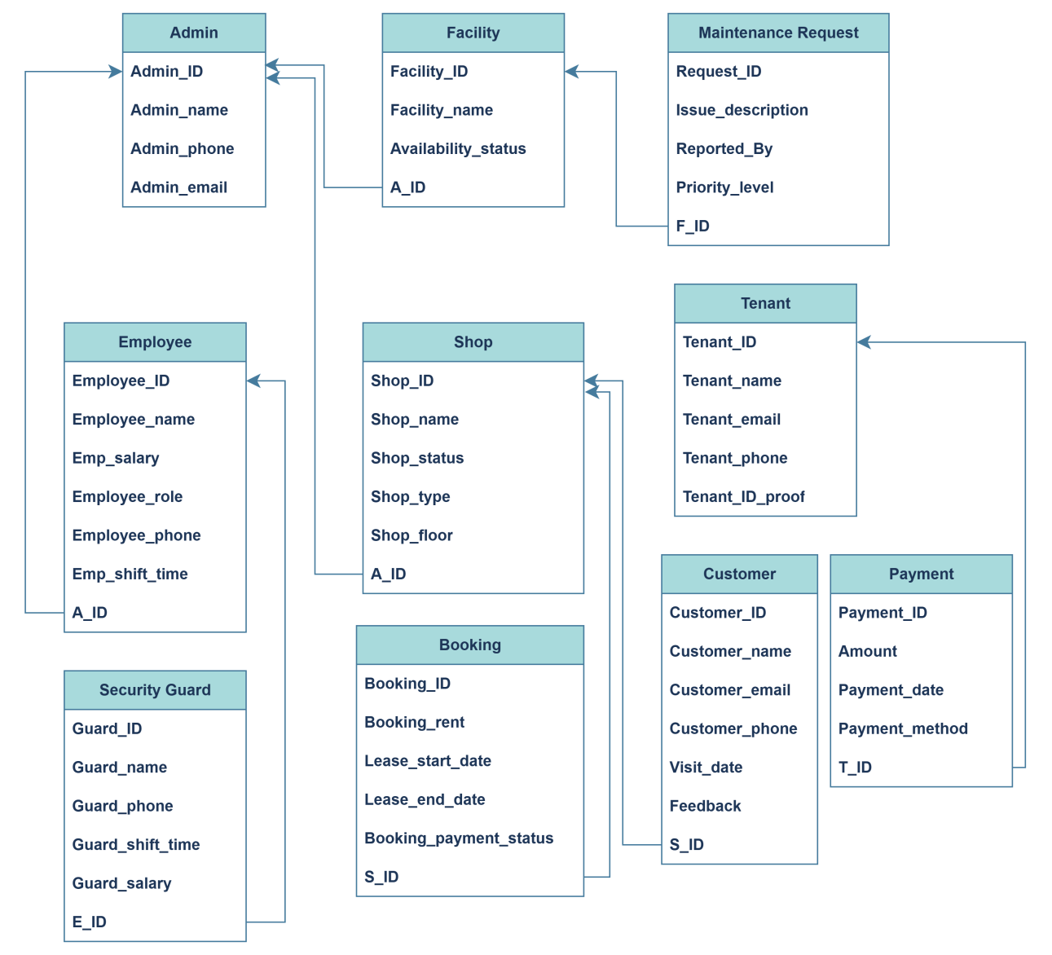

**8.Table Creation Using SQL**

**Created A separate Database/Schema for Mall_management_system:**

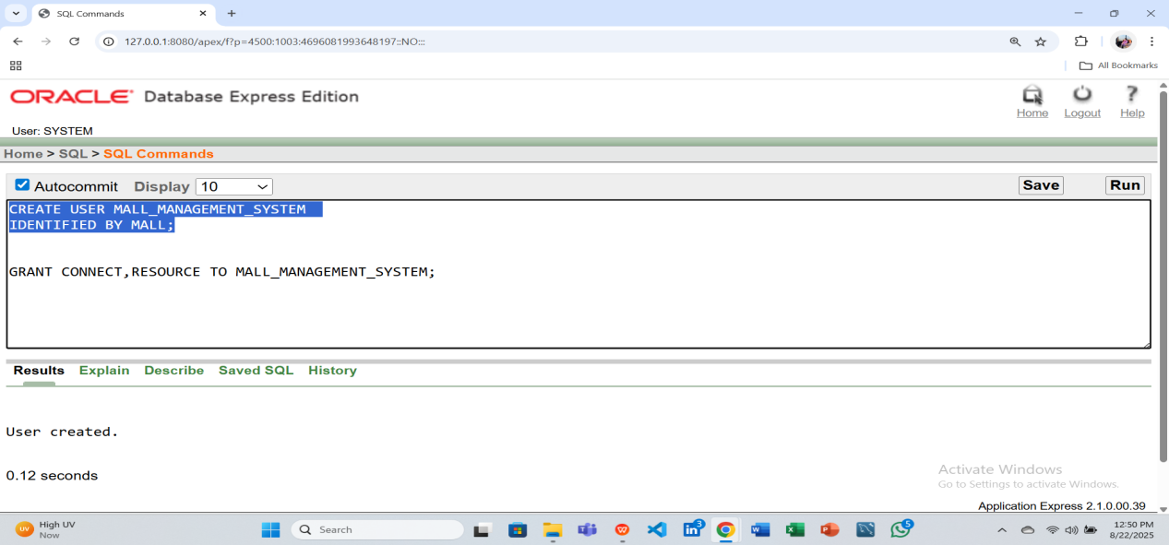

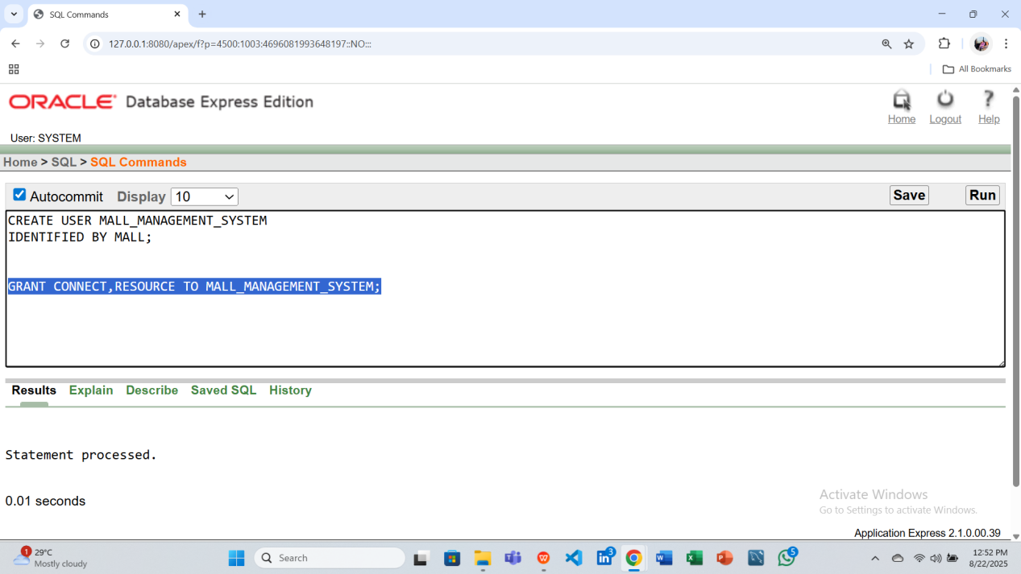

**Creating all Final Tables:**

-- 1. Admin

CREATE TABLE Admin (

Admin_ID INT PRIMARY KEY,

Admin_name VARCHAR(100) NOT NULL,

Admin_phone VARCHAR(15),

Admin_email VARCHAR(100) UNIQUE

);

DESCRIBE Admin

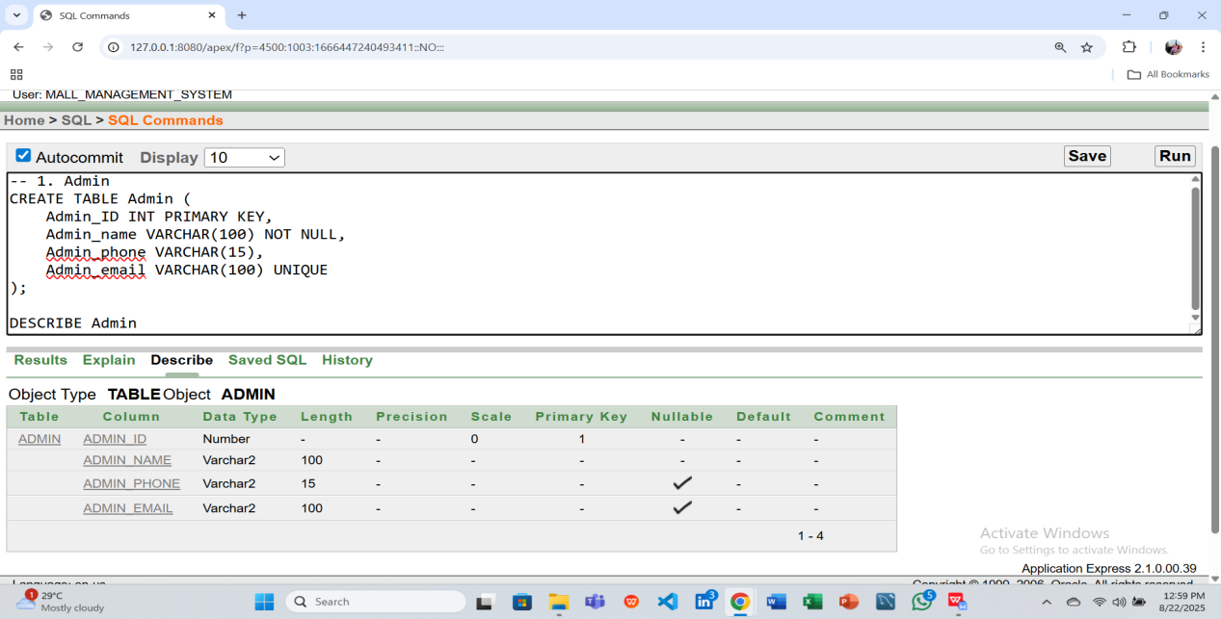

-- 2. Shop

CREATE TABLE Shop (

Shop_ID INT PRIMARY KEY,

Shop_name VARCHAR(100) NOT NULL,

Shop_status VARCHAR(20),

Shop_type VARCHAR(50),

Shop_floor INT,

A_ID INT,

FOREIGN KEY (A_ID) REFERENCES Admin(Admin_ID)

);

DESCRIBE Shop

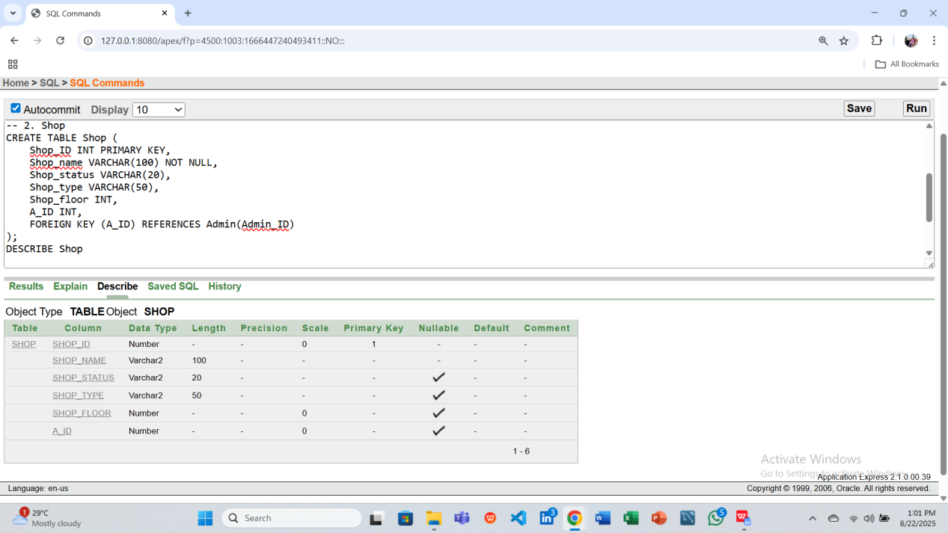

-- 3. Facility

CREATE TABLE Facility (

Facility_ID INT PRIMARY KEY,

Facility_name VARCHAR(100),

Availability_Status VARCHAR(20),

A_ID INT,

FOREIGN KEY (A_ID) REFERENCES Admin(Admin_ID)

);

DESCRIBE Facility

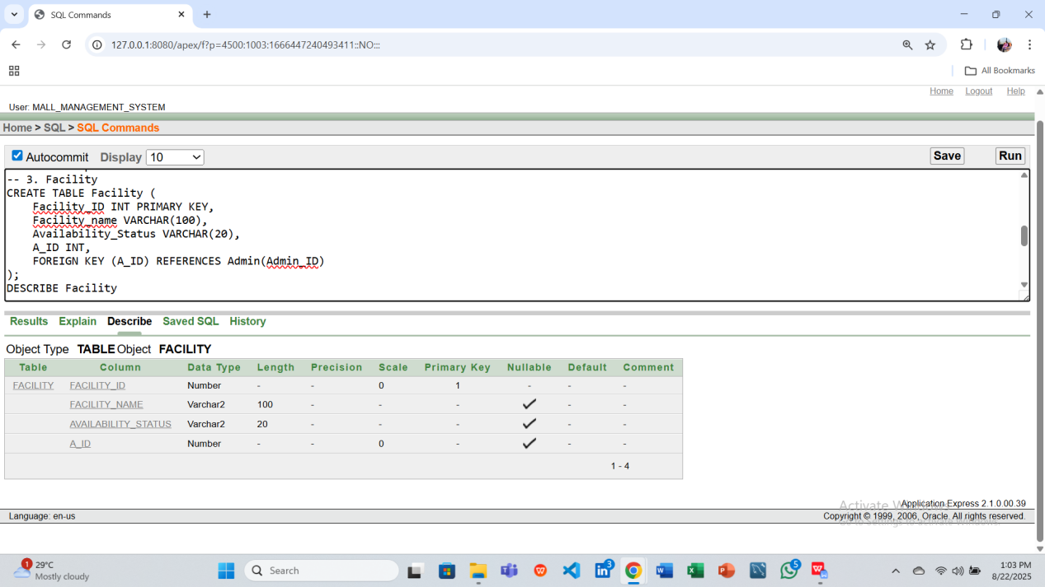

-- 4. Employee

CREATE TABLE Employee (

Employee_ID INT PRIMARY KEY,

Employee_name VARCHAR(100),

Emp_salary DECIMAL(10,2),

Employee_role VARCHAR(50),

Employee_phone VARCHAR(15),

Emp_shift_time VARCHAR(20),

A_ID INT,

FOREIGN KEY (A_ID) REFERENCES Admin(Admin_ID)

);

DESCRIBE Employee

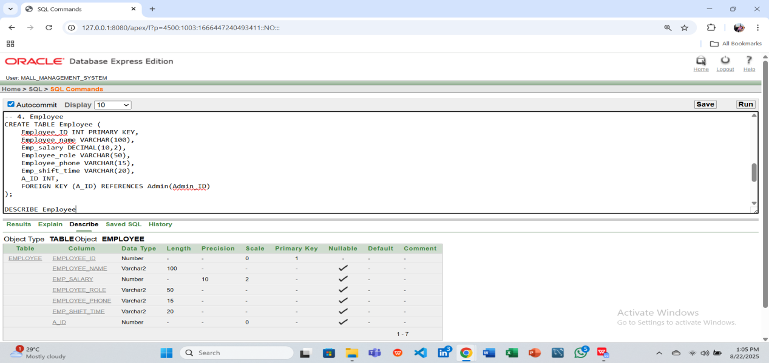

-- 5. Request

CREATE TABLE Request (

Request_ID INT PRIMARY KEY,

Issue_description VARCHAR(255),

Reported_by VARCHAR(100),

Priority_level VARCHAR(20),

F_ID INT,

FOREIGN KEY (F_ID) REFERENCES Facility(Facility_ID)

);

DESCRIBE Request

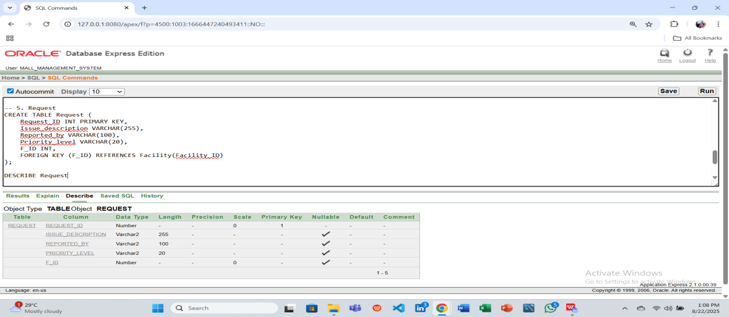

-- 6. Tenant

CREATE TABLE Tenant (

Tenant_ID INT PRIMARY KEY,

Tenant_name VARCHAR(100),

Tenant_email VARCHAR(100) UNIQUE,

Tenant_phone VARCHAR(15),

Tenant_ID_proof VARCHAR(50)

);

DESCRIBE Tenant

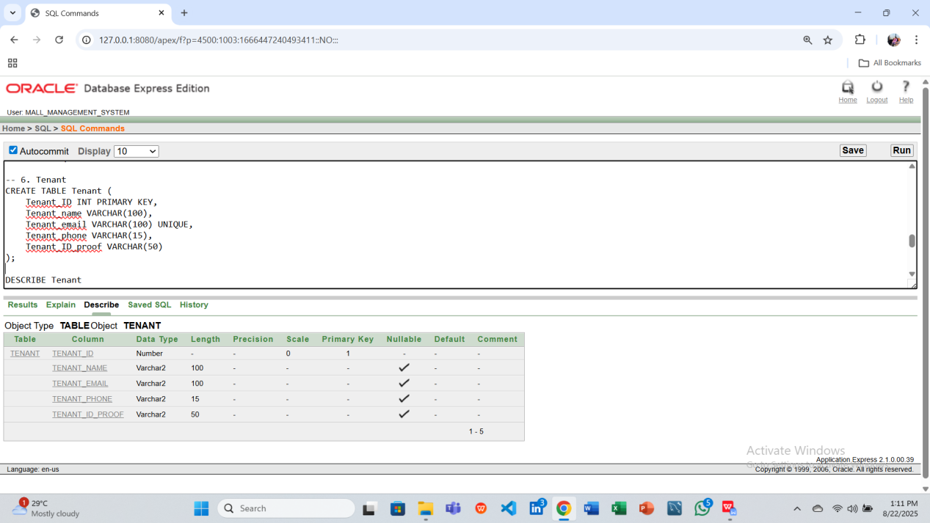

-- 7. Payment

CREATE TABLE Payment (

Payment_ID INT PRIMARY KEY,

Amount DECIMAL(10,2),

Payment_date DATE,

Payment_method VARCHAR(50),

T_ID INT,

FOREIGN KEY (T_ID) REFERENCES Tenant(Tenant_ID)

);

DESCRIBE Payment

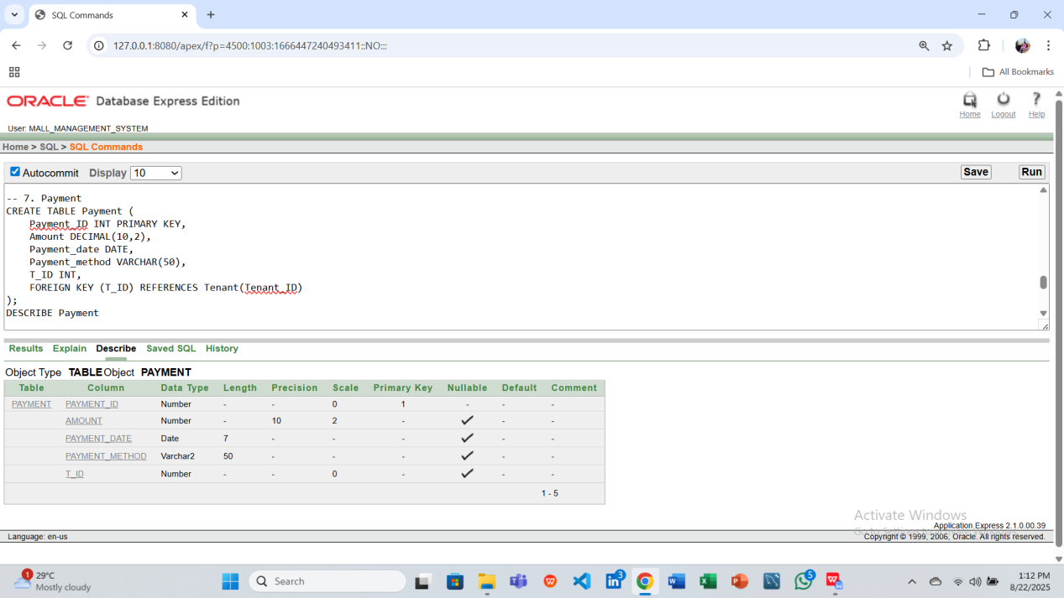

-- 8. Booking

CREATE TABLE Booking (

Booking_ID INT PRIMARY KEY,

Booking_rent DECIMAL(10,2),

Lease_start_date DATE,

Lease_end_date DATE,

Booking_payment_status VARCHAR(20),

S_ID INT,

FOREIGN KEY (S_ID) REFERENCES Shop(Shop_ID)

);

DESCRIBE Booking

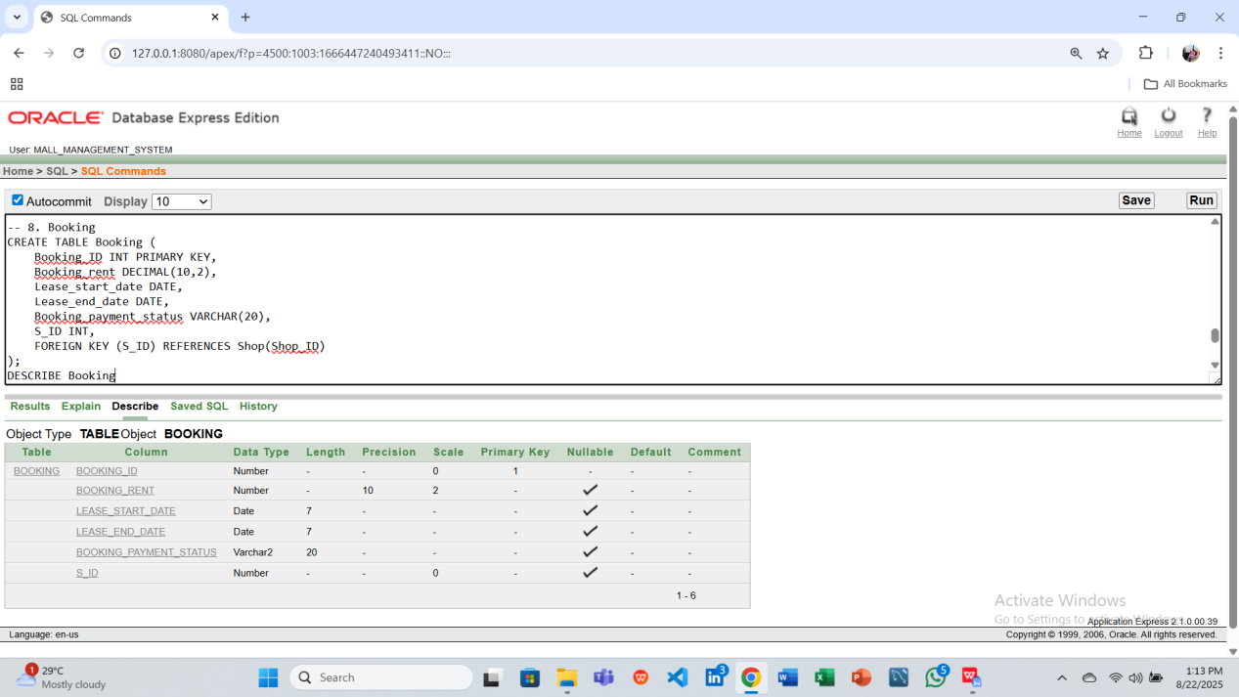

-- 9. Customer

CREATE TABLE Customer (

Customer_ID INT PRIMARY KEY,

Customer_name VARCHAR(100),

Customer_email VARCHAR(100),

Customer_phone VARCHAR(15),

Visit_date DATE,

Feedback VARCHAR(255),

S_ID INT,

FOREIGN KEY (S_ID) REFERENCES Shop(Shop_ID)

);

DESCRIBE Customer

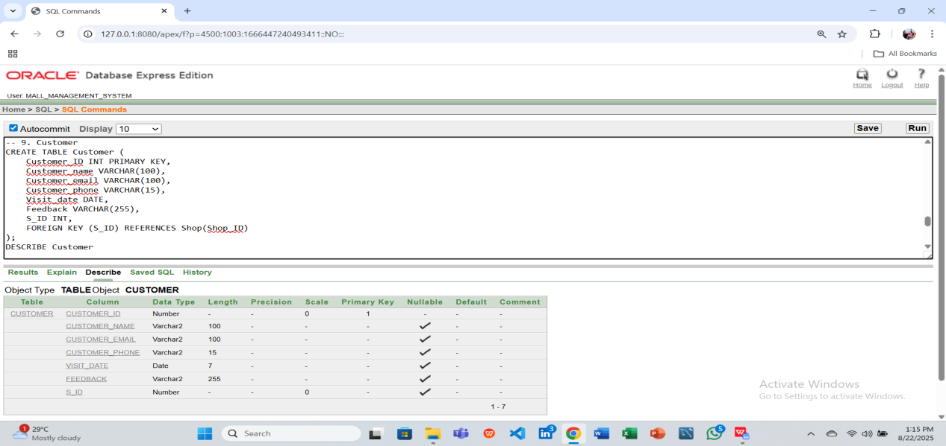

-- 10. Guard

CREATE TABLE Guard (

Guard_ID INT PRIMARY KEY,

Guard_name VARCHAR(100),

Guard_phone VARCHAR(15),

Guard_shift_time VARCHAR(20),

Guard_salary DECIMAL(10,2),

E_ID INT,

FOREIGN KEY (E_ID) REFERENCES Employee(Employee_ID)

);

DESCRIBE Guard

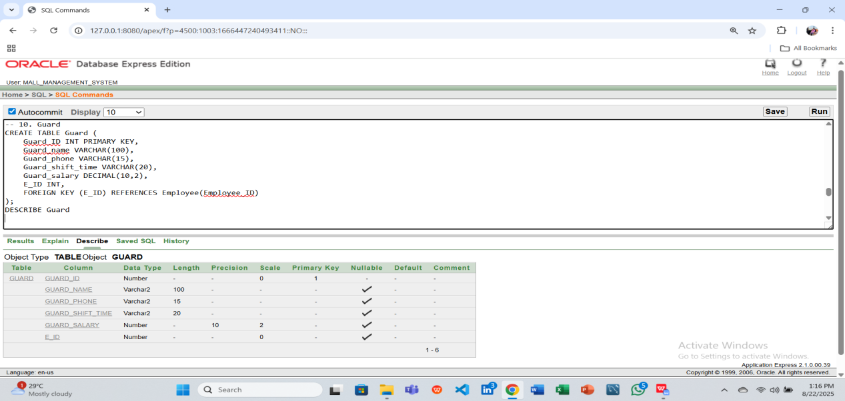

**9.Data Insertion**

-- Admin

INSERT INTO Admin VALUES (1, 'John Smith', '01710000001', 'john.smith@example.com');

INSERT INTO Admin VALUES (2, 'Emily Davis', '01710000002', 'emily.davis@example.com');

INSERT INTO Admin VALUES (3, 'Robert Wilson', '01710000003', 'robert.wilson@example.com');

INSERT INTO Admin VALUES (4, 'Sophia Brown', '01710000004', 'sophia.brown@example.com');

INSERT INTO Admin VALUES (5, 'David Lee', '01710000005', 'david.lee@example.com');

Select * from Admin;

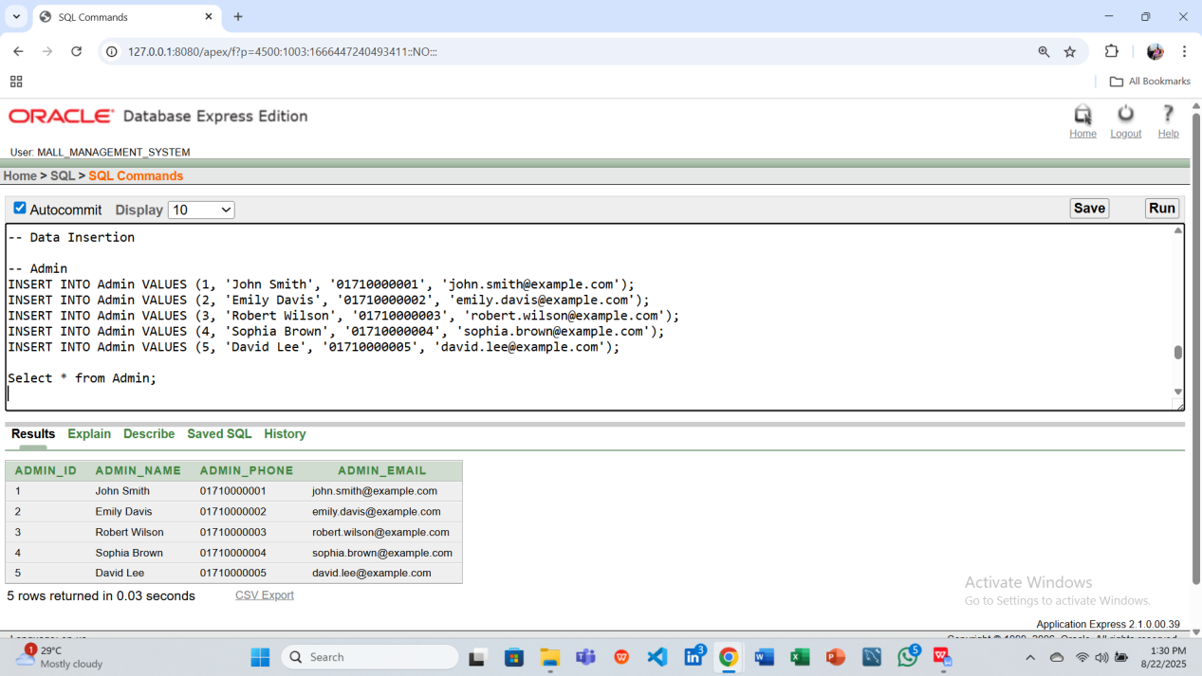

-- Shop

INSERT INTO Shop VALUES (101, 'Fashion Hub', 'Open', 'Clothing', 1, 1);

INSERT INTO Shop VALUES (102, 'Tech World', 'Open', 'Electronics', 2, 2);

INSERT INTO Shop VALUES (103, 'Book Corner', 'Closed', 'Books', 1, 3);

INSERT INTO Shop VALUES (104, 'Grocery Mart', 'Open', 'Groceries', 1, 4);

INSERT INTO Shop VALUES (105, 'Sports Zone', 'Open', 'Sports', 3, 5);

select * from Shop;

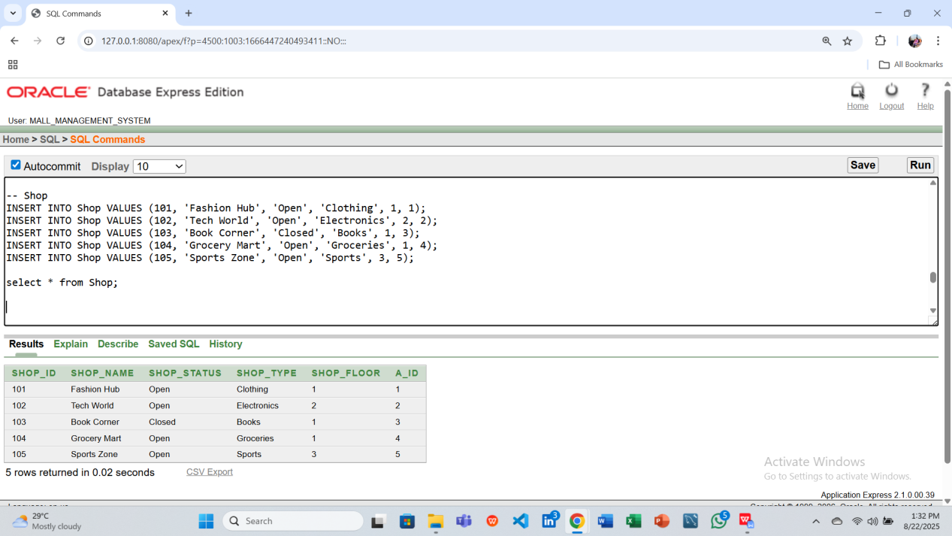

-- Facility

INSERT INTO Facility VALUES (201, 'Parking Lot', 'Available', 1);

INSERT INTO Facility VALUES (202, 'Food Court', 'Available', 2);

INSERT INTO Facility VALUES (203, 'Play Area', 'Under Maintenance', 3);

INSERT INTO Facility VALUES (204, 'Cinema Hall', 'Available', 4);

INSERT INTO Facility VALUES (205, 'ATM Booth', 'Available', 5);

select * from Facility;

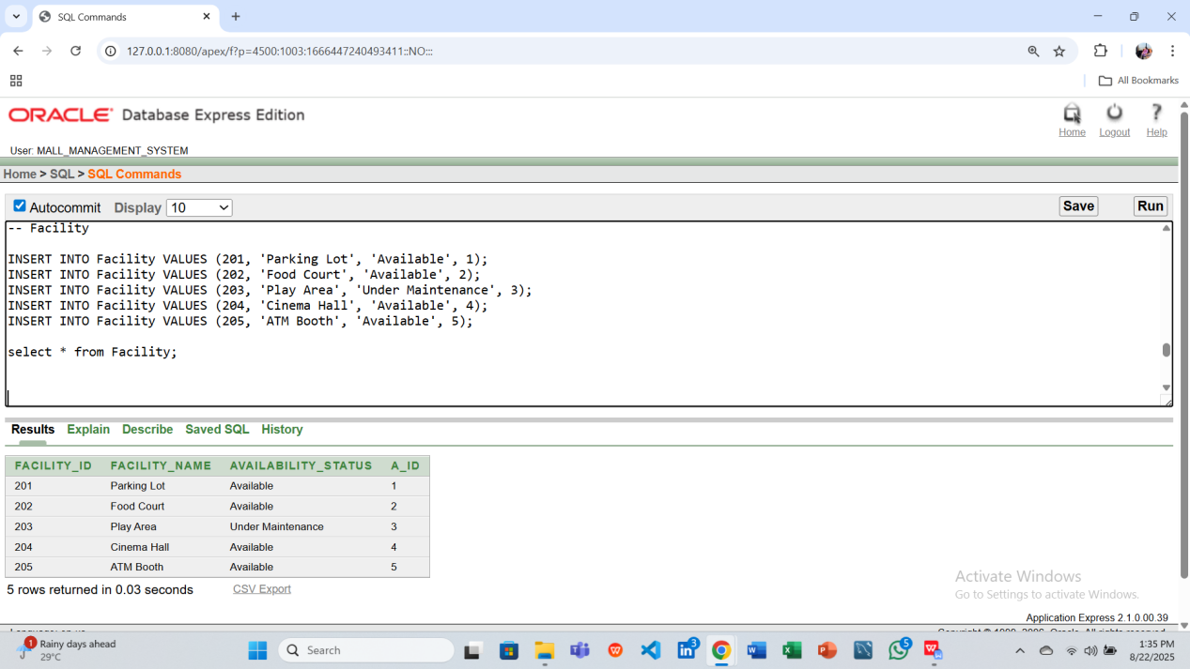

-- Employee

INSERT INTO Employee VALUES (301, 'Alex Johnson', 25000, 'Manager', '01710000011', 'Morning', 1);

INSERT INTO Employee VALUES (302, 'Sarah Lee', 18000, 'Cashier', '01710000012', 'Evening', 2);

INSERT INTO Employee VALUES (303, 'Mark Adams', 22000, 'Supervisor', '01710000013', 'Night', 3);

INSERT INTO Employee VALUES (304, 'Emma Clark', 17000, 'Salesperson', '01710000014', 'Morning', 4);

INSERT INTO Employee VALUES (305, 'Daniel Evans', 24000, 'Technician', '01710000015', 'Evening', 5);

select * from Employee;

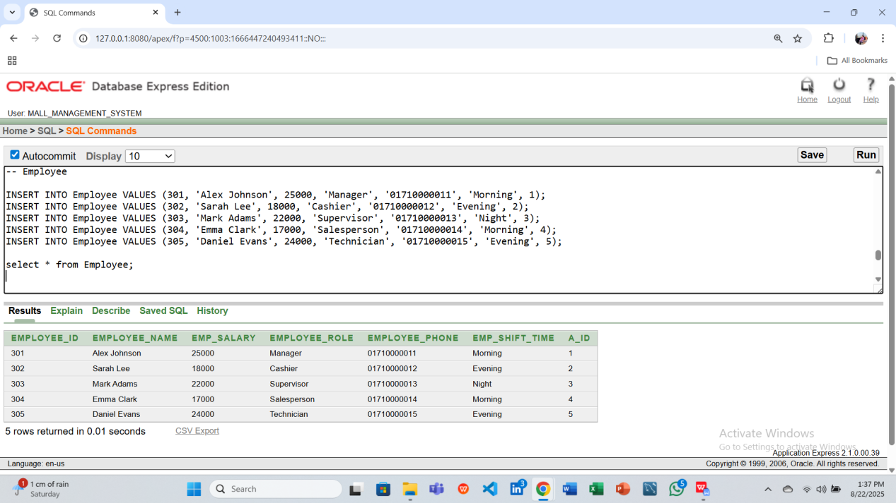

-- Request

INSERT INTO Request VALUES (401, 'Broken AC in Food Court', 'Manager', 'High', 202);

INSERT INTO Request VALUES (402, 'Lighting issue in Parking', 'Guard', 'Medium', 201);

INSERT INTO Request VALUES (403, 'Play area swings damaged', 'Customer', 'High', 203);

INSERT INTO Request VALUES (404, 'Cinema projector not working', 'Technician', 'High', 204);

INSERT INTO Request VALUES (405, 'ATM cash refill request', 'Customer', 'Medium', 205);

select * from Request;

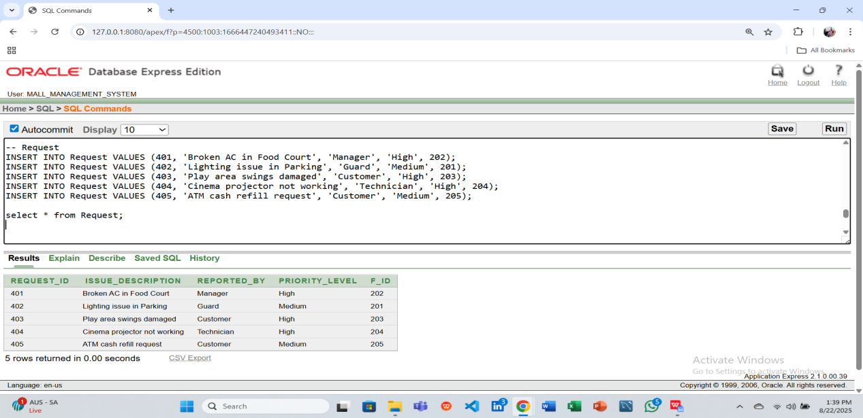

-- Tenant

INSERT INTO Tenant VALUES (501, 'Michael Brown', 'michael.brown@example.com', '01710000021', 'NID123456');

INSERT INTO Tenant VALUES (502, 'Sophia Turner', 'sophia.turner@example.com', '01710000022', 'NID654321');

INSERT INTO Tenant VALUES (503, 'Liam Harris', 'liam.harris@example.com', '01710000023', 'NID112233');

INSERT INTO Tenant VALUES (504, 'Emma Wright', 'emma.wright@example.com', '01710000024', 'NID445566');

INSERT INTO Tenant VALUES (505, 'Noah King', 'noah.king@example.com', '01710000025', 'NID778899');

select * from Tenant;

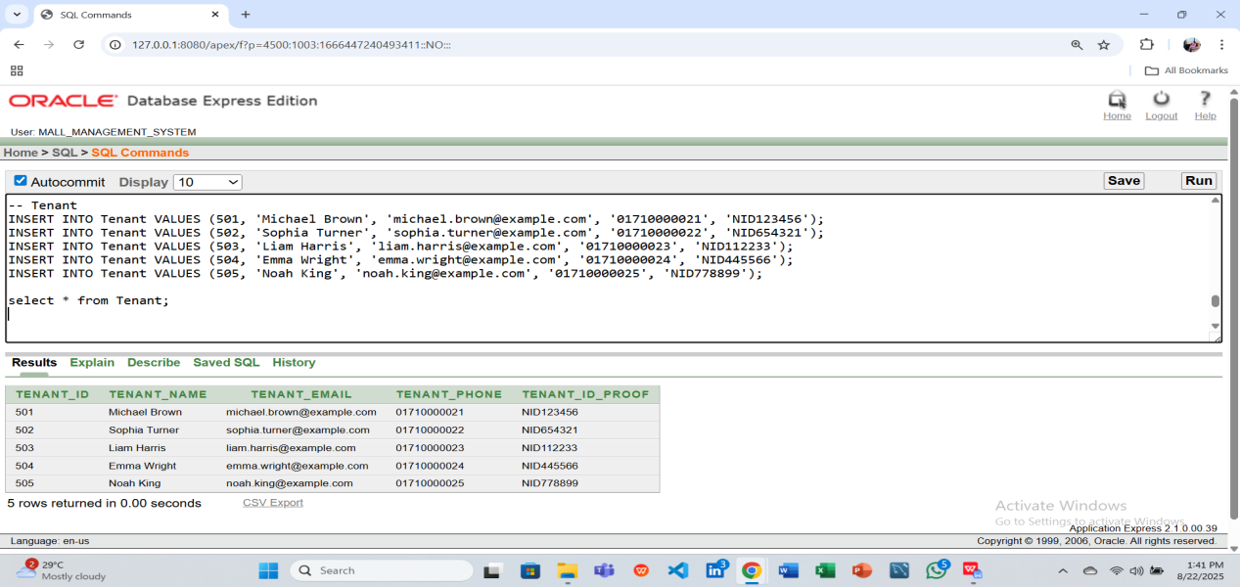

-- Payment

INSERT INTO Payment VALUES (601, 15000, TO_DATE('2025-08-01','YYYY-MM-DD'), 'Cash', 501);

INSERT INTO Payment VALUES (602, 12000, TO_DATE('2025-08-02','YYYY-MM-DD'), 'Bank Transfer', 502);

INSERT INTO Payment VALUES (603, 18000, TO_DATE('2025-08-03','YYYY-MM-DD'), 'Card', 503);

INSERT INTO Payment VALUES (604, 16000, TO_DATE('2025-08-04','YYYY-MM-DD'), 'Cash', 504);

INSERT INTO Payment VALUES (605, 14000, TO_DATE('2025-08-05','YYYY-MM-DD'), 'Bank Transfer', 505);

select * from Payment;

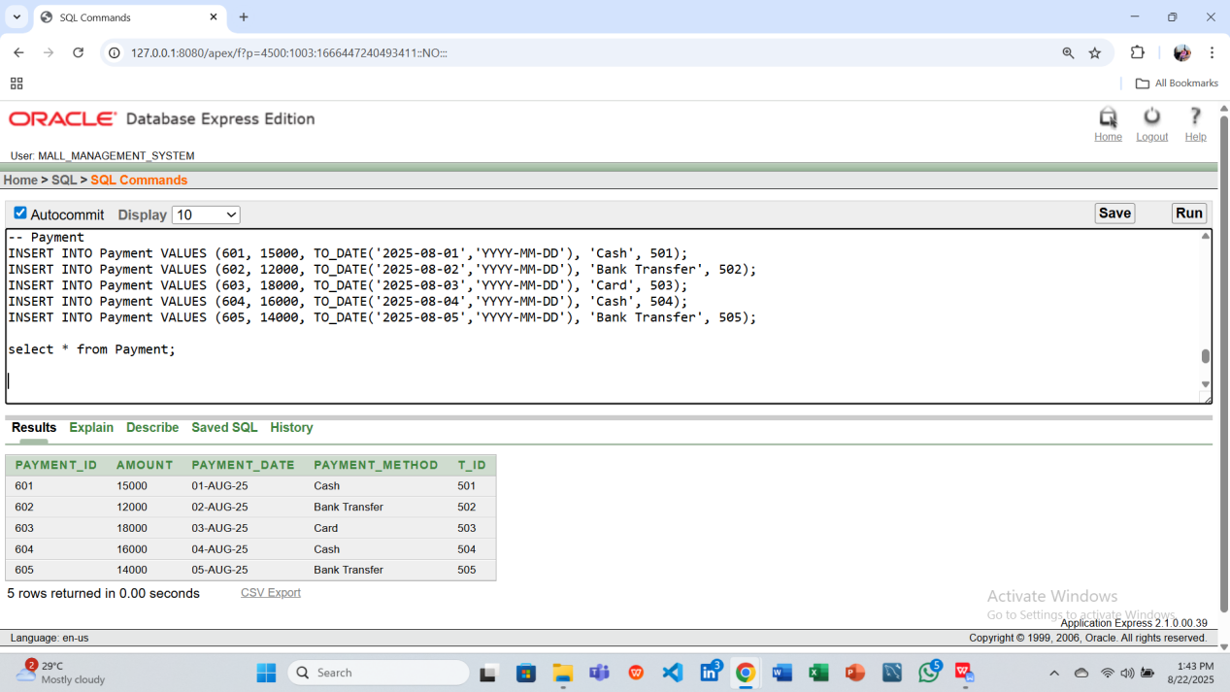

-- Booking

INSERT INTO Booking VALUES

(701, 20000, TO_DATE('2025-08-01','YYYY-MM-DD'), TO_DATE('2026-07-31','YYYY-MM-DD'), 'Paid', 101);

INSERT INTO Booking VALUES

(702, 25000, TO_DATE('2025-08-02','YYYY-MM-DD'), TO_DATE('2026-08-01','YYYY-MM-DD'), 'Unpaid', 102);

INSERT INTO Booking VALUES

(703, 18000, TO_DATE('2025-08-03','YYYY-MM-DD'), TO_DATE('2026-08-02','YYYY-MM-DD'), 'Paid', 103);

INSERT INTO Booking VALUES

(704, 22000, TO_DATE('2025-08-04','YYYY-MM-DD'), TO_DATE('2026-08-03','YYYY-MM-DD'), 'Paid', 104);

INSERT INTO Booking VALUES

(705, 24000, TO_DATE('2025-08-05','YYYY-MM-DD'), TO_DATE('2026-08-04','YYYY-MM-DD'), 'Unpaid', 105);

select * from Booking;

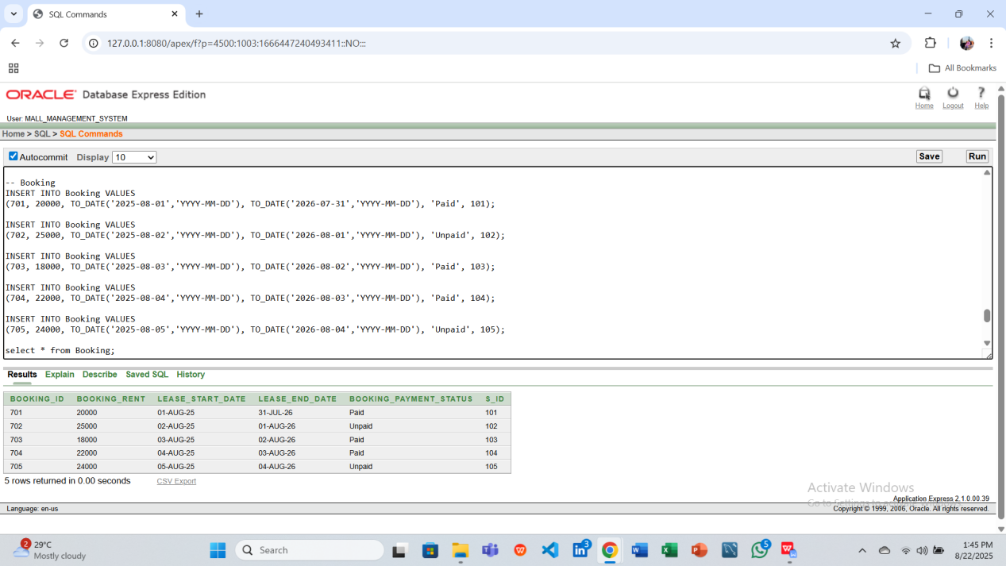

-- Customer

INSERT INTO Customer VALUES (801, 'Liam Wilson', 'liam.wilson@example.com', '01710000031', TO_DATE('2025-08-01','YYYY-MM-DD'), 'Great service', 101);

INSERT INTO Customer VALUES (802, 'Olivia White', 'olivia.white@example.com', '01710000032', TO_DATE('2025-08-02','YYYY-MM-DD'), 'Nice products', 102);

INSERT INTO Customer VALUES (803, 'Noah Thompson', 'noah.thompson@example.com', '01710000033', TO_DATE('2025-08-03','YYYY-MM-DD'), 'Loved the store', 103);

INSERT INTO Customer VALUES (804, 'Emma Martinez', 'emma.martinez@example.com', '01710000034', TO_DATE('2025-08-04','YYYY-MM-DD'), 'Helpful staff', 104);

INSERT INTO Customer VALUES (805, 'Lucas Robinson', 'lucas.robinson@example.com', '01710000035', TO_DATE('2025-08-05','YYYY-MM-DD'), 'Affordable prices', 105);

select * from Customer;

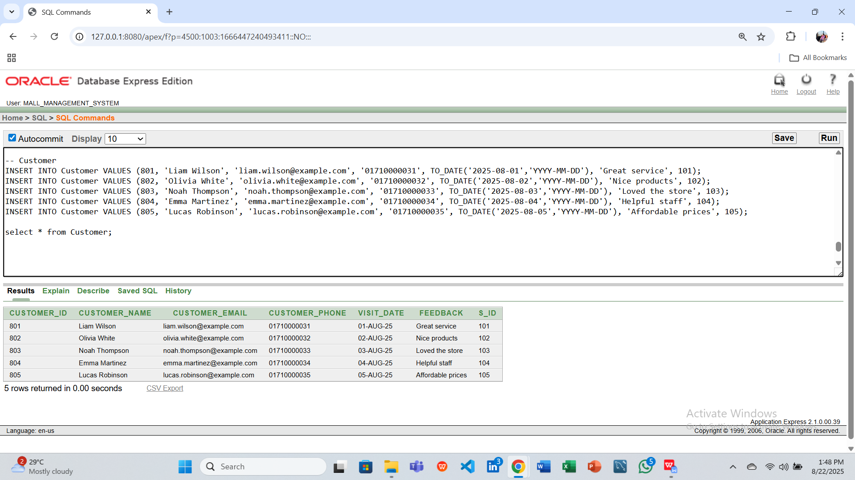

-- Guard

INSERT INTO Guard VALUES (901, 'David Miller', '01710000041', 'Night', 15000, 301);

INSERT INTO Guard VALUES (902, 'Emma Scott', '01710000042', 'Day', 14000, 302);

INSERT INTO Guard VALUES (903, 'Liam Parker', '01710000043', 'Night', 15500, 303);

INSERT INTO Guard VALUES (904, 'Sophia Hall', '01710000044', 'Day', 14500, 304);

INSERT INTO Guard VALUES (905, 'Ethan Lewis', '01710000045', 'Night', 16000, 305);

select * from Guard;

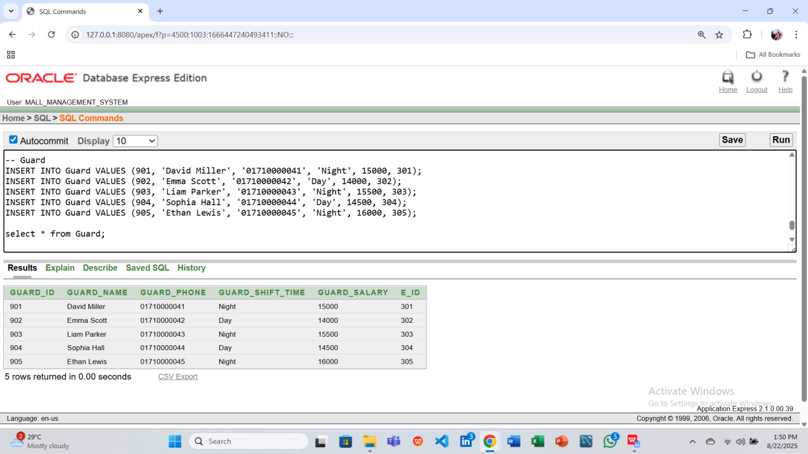

**10.Query Writing Using PL/SQL**

**11. Basic PL/SQL**

**- Using 2 variables**

**Question 1: Display the salary of Employee_ID = 301 using a variable.**

**Answer:**

DECLARE

v_emp_salary NUMBER(10,2);

BEGIN

SELECT Emp_salary INTO v_emp_salary

FROM Employee

WHERE Employee_ID = 301;

DBMS_OUTPUT.PUT_LINE('Employee Salary: ' || v_emp_salary);

END;

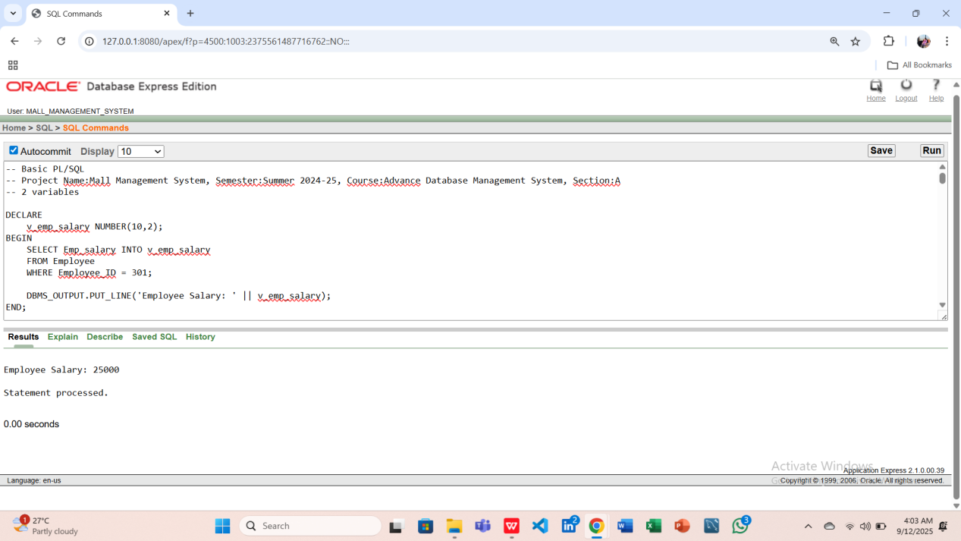

**Question 2: Display the total salary of guards reporting to Employee_ID = 301 using a variable.**

**Answer:**

DECLARE

v_guard_salary NUMBER(10,2);

BEGIN

SELECT SUM(Guard_salary) INTO v_guard_salary

FROM Guard

WHERE E_ID = 301;

DBMS_OUTPUT.PUT_LINE('Total Guard Salary under Employee: ' || NVL(v_guard_salary, 0));

END;

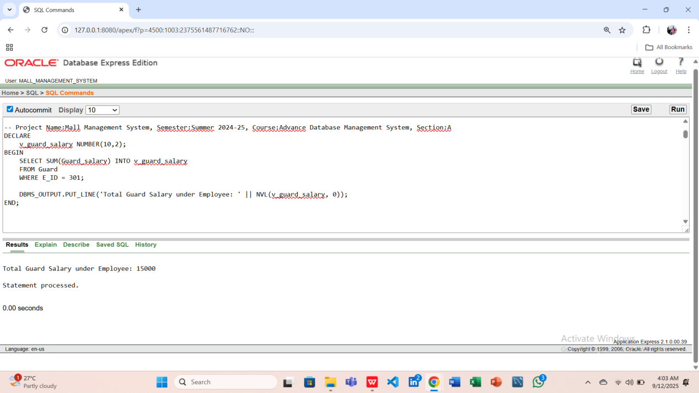

**-Using 2 Operators**

**Question 1: Calculate Balance using Subtraction Operator**

**Answer:**

DECLARE

v_payment_amount NUMBER(10,2);

v_booking_rent NUMBER(10,2);

v_balance NUMBER(10,2);

BEGIN

SELECT Amount INTO v_payment_amount

FROM Payment

WHERE T_ID = 501;

SELECT Booking_rent INTO v_booking_rent

FROM Booking

WHERE S_ID = 101;

-- Operator 1: subtraction

v_balance := v_payment_amount - v_booking_rent;

DBMS_OUTPUT.PUT_LINE('Balance after subtraction: ' || v_balance);

END;

/

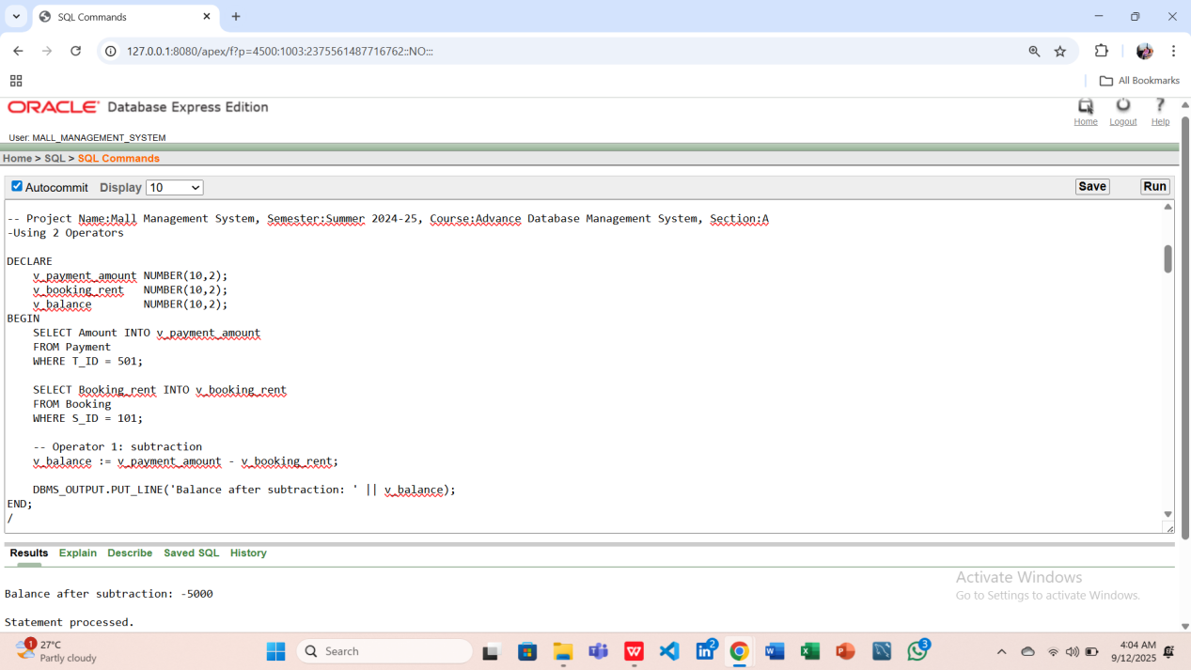

**Question 2: Check if Balance is Positive or Negative using Comparison Operator**

**Answer:**

DECLARE

v_payment_amount NUMBER(10,2);

v_booking_rent NUMBER(10,2);

v_balance NUMBER(10,2);

BEGIN

SELECT Amount INTO v_payment_amount

FROM Payment

WHERE T_ID = 501;

SELECT Booking_rent INTO v_booking_rent

FROM Booking

WHERE S_ID = 101;

v_balance := v_payment_amount - v_booking_rent;

-- Operator 2: comparison

IF v_balance >= 0 THEN

DBMS_OUTPUT.PUT_LINE('Balance is Positive: ' || v_balance);

ELSE

DBMS_OUTPUT.PUT_LINE('Balance is Negative: ' || v_balance);

END IF;

END;

/

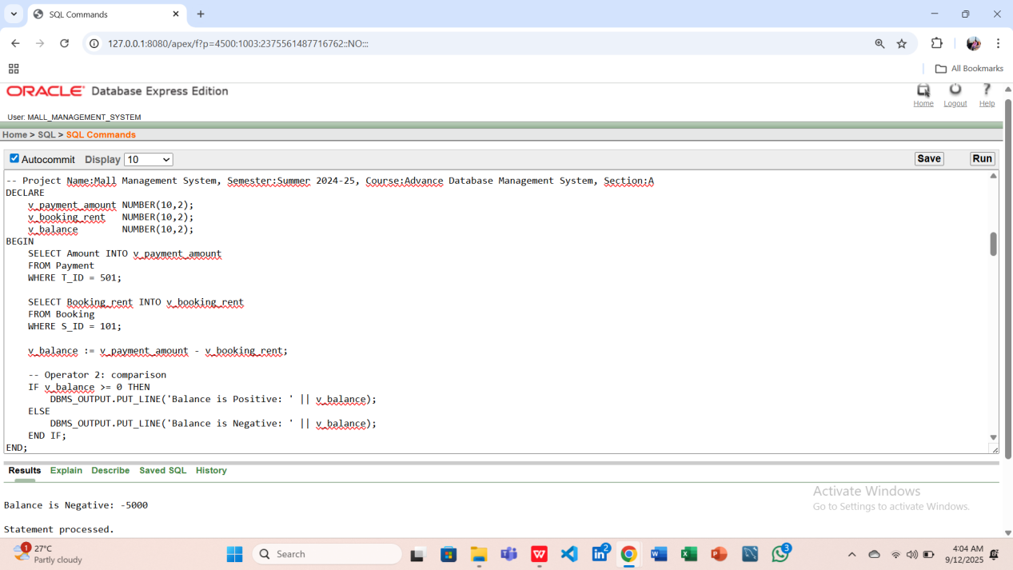

**-Using 2 single-row function**

**Question 1: Display the total payment made by a tenant.**

**Answer:**

DECLARE

v_payment_amount NUMBER(10,2);

BEGIN

SELECT NVL(Amount,0) INTO v_payment_amount

FROM Payment

WHERE T_ID = 501;

DBMS_OUTPUT.PUT_LINE('Total Payment by Tenant 501: ' || v_payment_amount);

END;

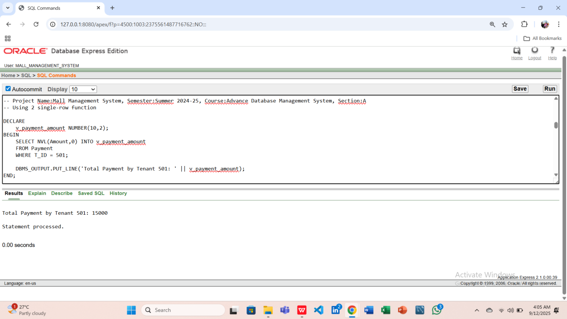

**Question 2: Display the booking rent for a shop.**

**Answer:**

DECLARE

v_booking_rent NUMBER(10,2);

BEGIN

SELECT ROUND(Booking_rent, 2) INTO v_booking_rent

FROM Booking

WHERE S_ID = 101;

DBMS_OUTPUT.PUT_LINE('Booking Rent for Shop 101: ' || v_booking_rent);

END;

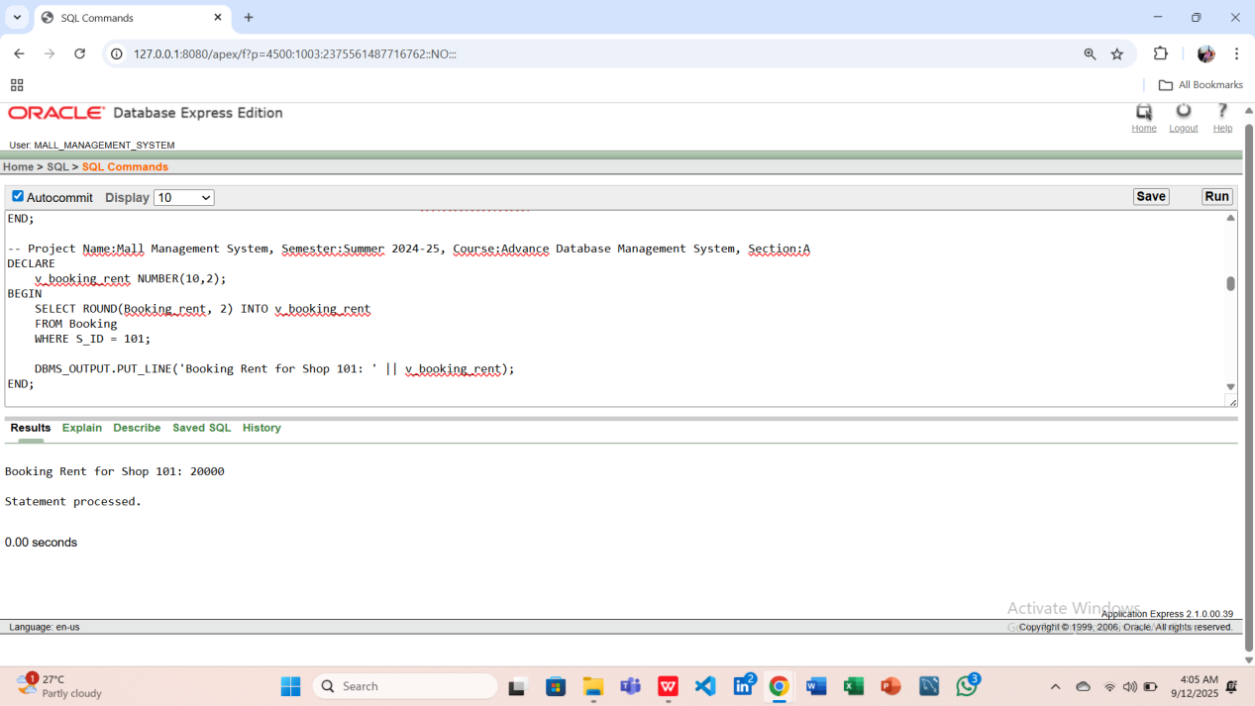

**- Using 2 group function**

**Question 1: Find the Total Payment Amount**

**Answer:**

DECLARE

v_total NUMBER(10,2);

BEGIN

SELECT SUM(Amount) INTO v_total

FROM Payment;

DBMS_OUTPUT.PUT_LINE('Total Payment: ' || v_total);

END;

/

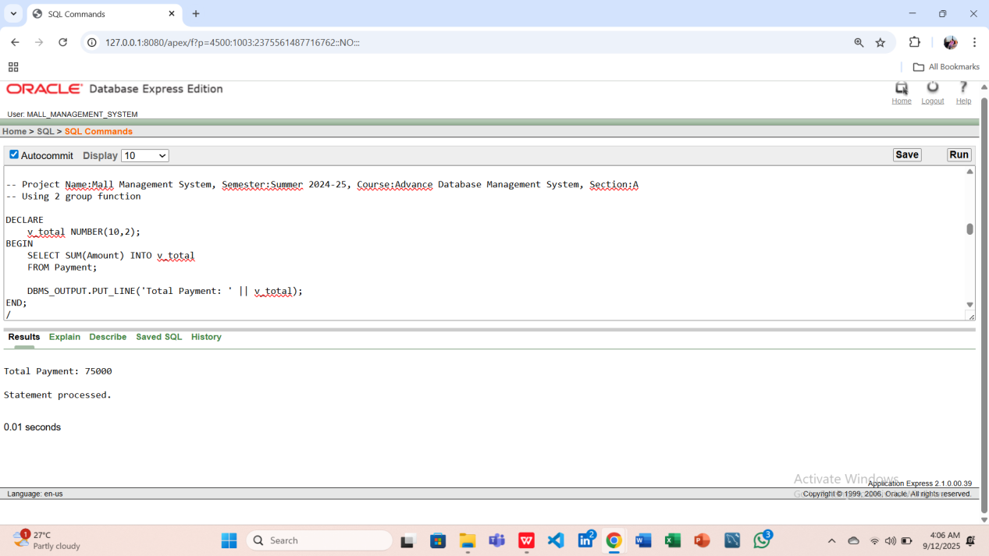

**Question 2: Find the Average Payment Amount**

**Answer:**

DECLARE

v_avg NUMBER(10,2);

BEGIN

SELECT AVG(Amount) INTO v_avg

FROM Payment;

DBMS_OUTPUT.PUT_LINE('Average Payment: ' || v_avg);

END;

/

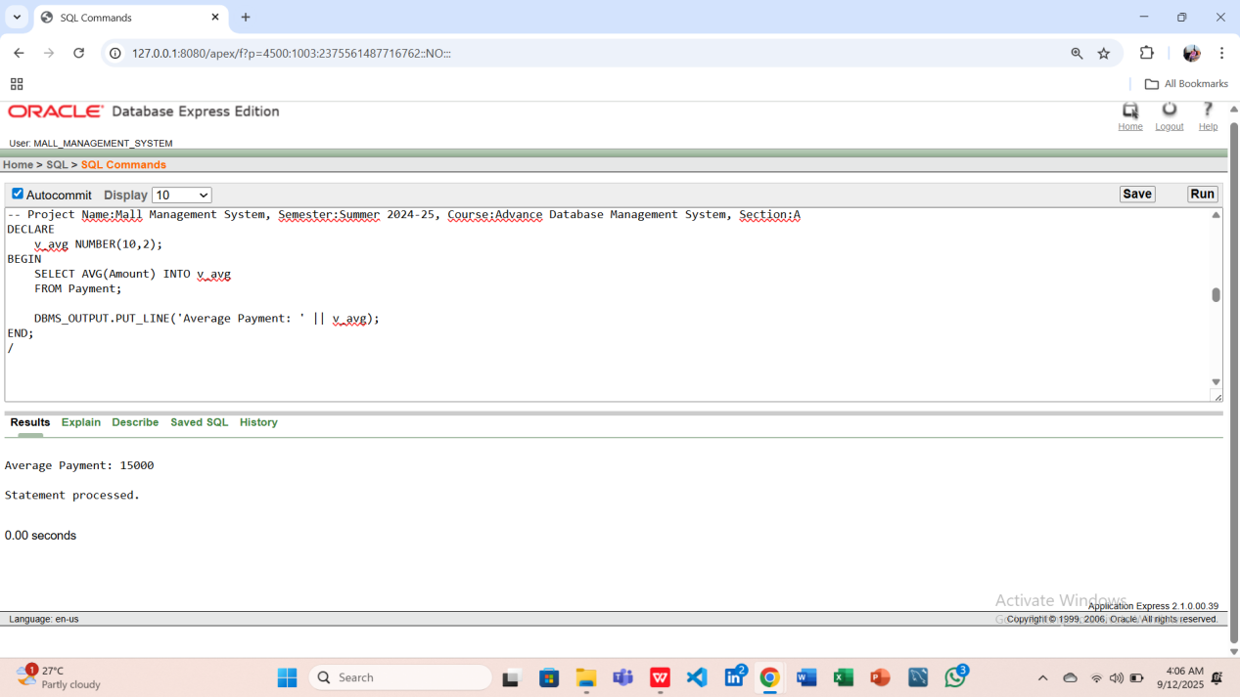

**-Using 2 loop**

**Question 1: Display Shop IDs from 101 to 105 (Numeric FOR Loop)**

**Answer:**

DECLARE

BEGIN

-- Loop 1: Numeric FOR loop

FOR i IN 101..105 LOOP

DBMS_OUTPUT.PUT_LINE('Shop ID: ' || i);

END LOOP;

END;

/

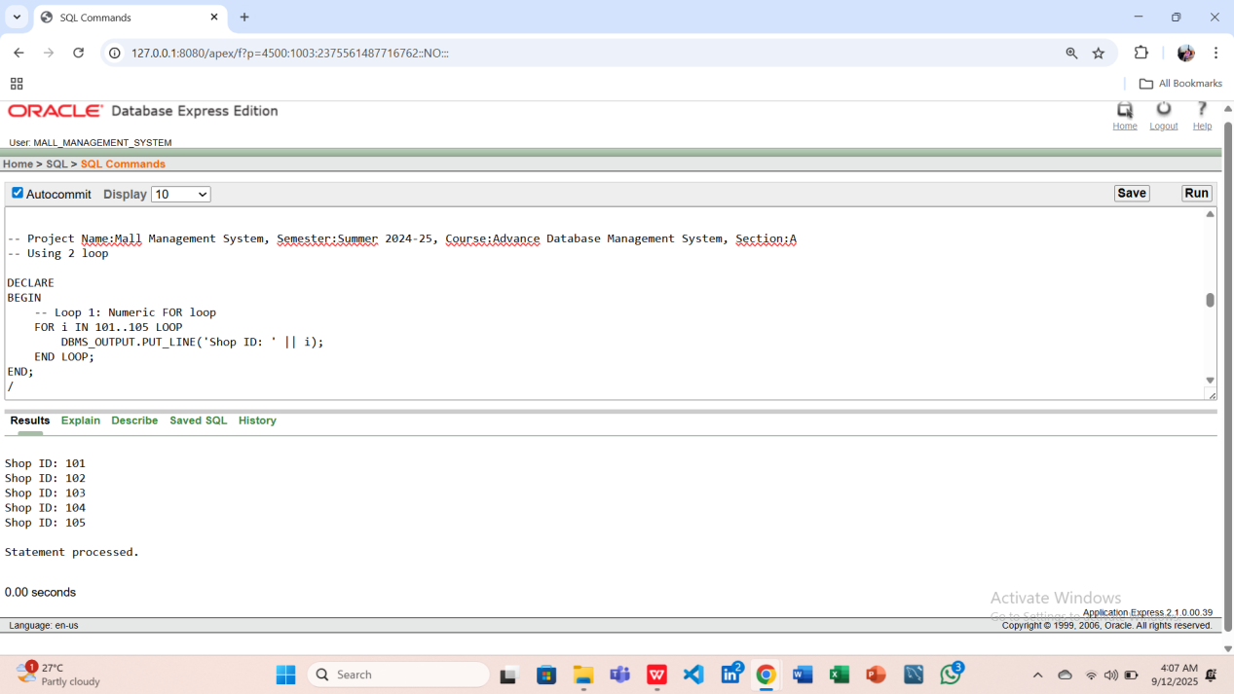

**Question 2: Display Shop IDs from 201 to 205 (WHILE Loop)**

**Answer:**

DECLARE

i NUMBER := 201;

BEGIN

-- Loop 2: WHILE loop

WHILE i <= 205 LOOP

DBMS_OUTPUT.PUT_LINE('Shop ID: ' || i);

i := i + 1;

END LOOP;

END;

/

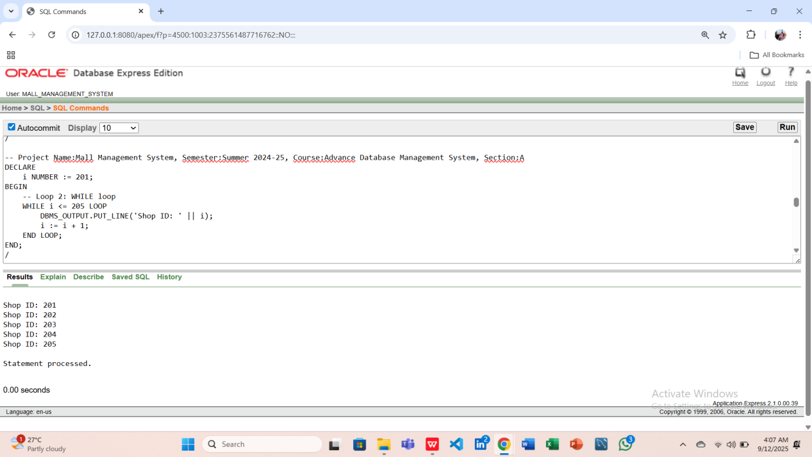

**-2 conditional statements**

**Question 1: Check Booking Payment Status using IF–ELSE**

**Answer:**

DECLARE

v_status Booking.Booking_payment_status%TYPE;

BEGIN

SELECT Booking_payment_status INTO v_status

FROM Booking

WHERE Booking_ID = 702;

-- Conditional statement 1: IF–ELSE

IF v_status = 'Paid' THEN

DBMS_OUTPUT.PUT_LINE('Booking is Paid');

ELSE

DBMS_OUTPUT.PUT_LINE('Booking is Not Paid');

END IF;

END;

/

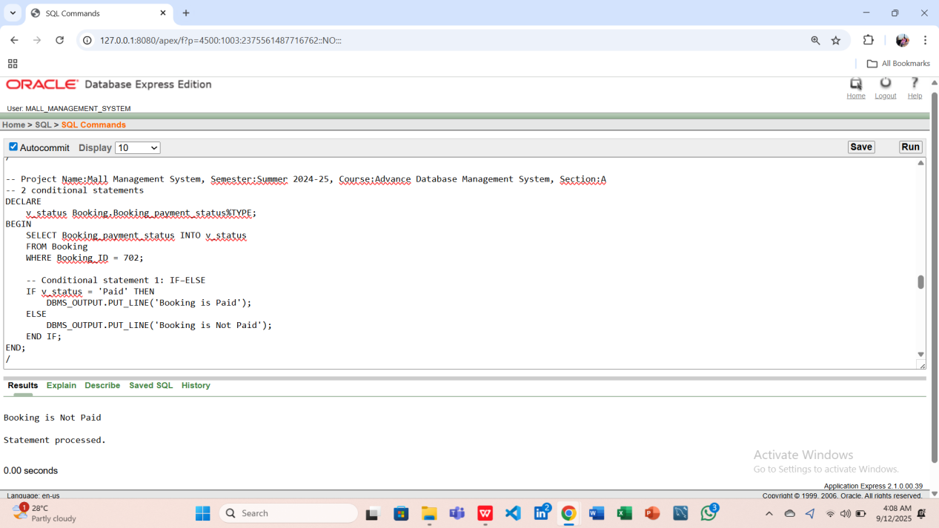

**Question 2: Check Booking Payment Status using CASE**

**Answer:**

DECLARE

v_status Booking.Booking_payment_status%TYPE;

BEGIN

SELECT Booking_payment_status INTO v_status

FROM Booking

WHERE Booking_ID = 702;

-- Conditional statement 2: CASE

CASE v_status

WHEN 'Paid' THEN

DBMS_OUTPUT.PUT_LINE('Status = Paid');

WHEN 'Unpaid' THEN

DBMS_OUTPUT.PUT_LINE('Status = Unpaid');

ELSE

DBMS_OUTPUT.PUT_LINE('Status Unknown');

END CASE;

END;

/

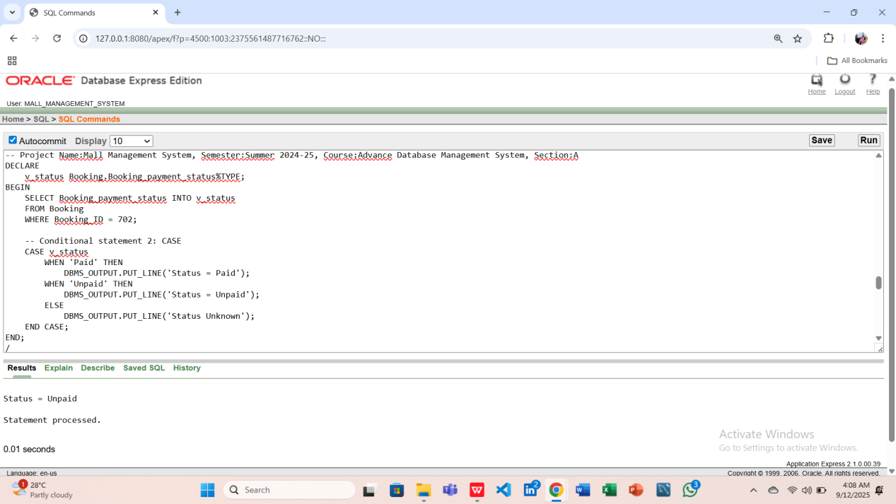

**-2 subquery**

**Question 1: Find Employee Name with Maximum Salary (Subquery in WHERE clause)**

**Answer:**

DECLARE

v_emp_name Employee.Employee_name%TYPE;

BEGIN

SELECT Employee_name INTO v_emp_name

FROM Employee

WHERE Emp_salary = (SELECT MAX(Emp_salary) FROM Employee);

DBMS_OUTPUT.PUT_LINE('Employee with Max Salary: ' || v_emp_name);

END;

/

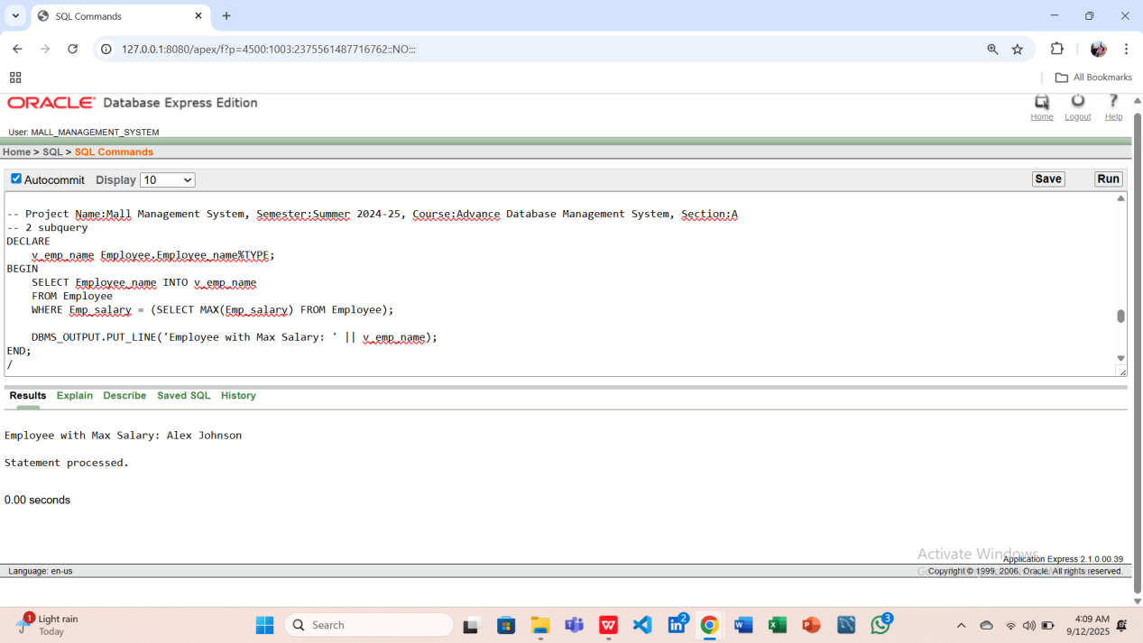

**Question 2: Find Shop Managed by Admin 'Emily Davis' (Subquery in WHERE clause)**

**Answer:**

DECLARE

v_shop_name Shop.Shop_name%TYPE;

BEGIN

SELECT Shop_name INTO v_shop_name

FROM Shop

WHERE A_ID = (SELECT Admin_ID FROM Admin WHERE Admin_name = 'Emily Davis');

DBMS_OUTPUT.PUT_LINE('Shop managed by Emily Davis: ' || v_shop_name);

END;

/

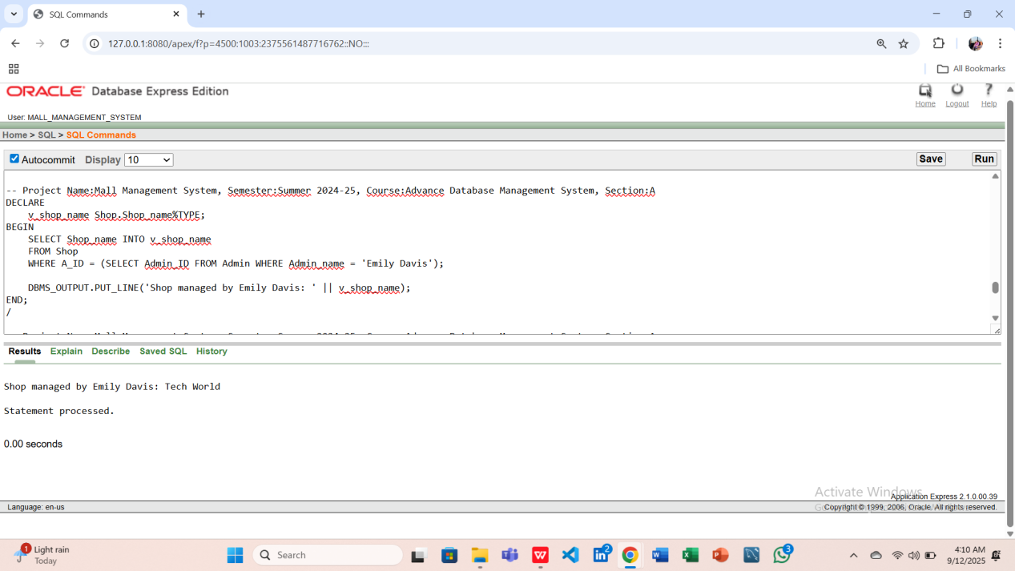

**-2 joining**

**Question 1: Display One Employee and Guard Name (JOIN)**

**Answer:**

DECLARE

v_emp_name Employee.Employee_name%TYPE;

v_guard_name Guard.Guard_name%TYPE;

BEGIN

SELECT E.Employee_name, G.Guard_name

INTO v_emp_name, v_guard_name

FROM Employee E

JOIN Guard G ON E.Employee_ID = G.E_ID

WHERE E.Employee_ID = 301; -- example for one employee

DBMS_OUTPUT.PUT_LINE('Employee: ' || v_emp_name || ' | Guard: ' || v_guard_name);

END;

/

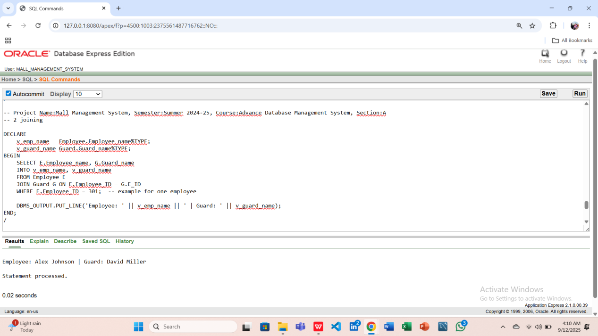

**Question 2: Display One Shop and Admin Name (JOIN)**

**Answer:**

DECLARE

v_shop_name Shop.Shop_name%TYPE;

v_admin_name Admin.Admin_name%TYPE;

BEGIN

SELECT S.Shop_name, A.Admin_name

INTO v_shop_name, v_admin_name

FROM Shop S

JOIN Admin A ON S.A_ID = A.Admin_ID

WHERE S.Shop_ID = 101; -- example for one shop

DBMS_OUTPUT.PUT_LINE('Shop: ' || v_shop_name || ' | Admin: ' || v_admin_name);

END;

/

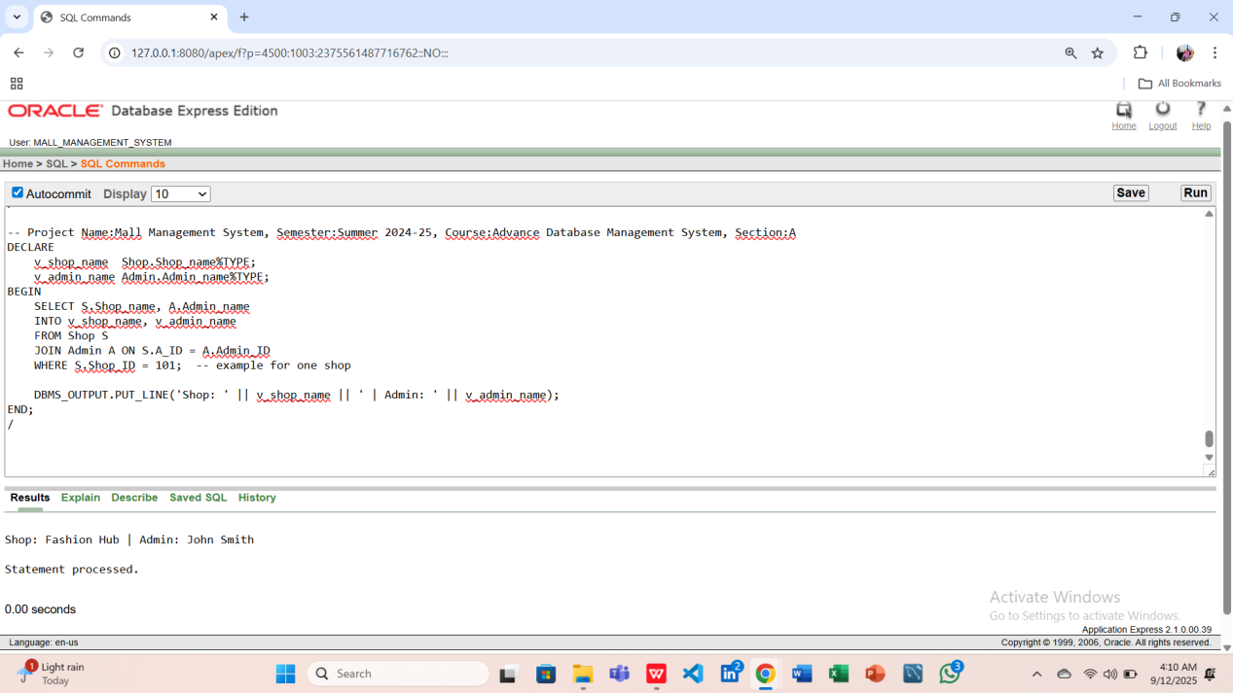

1. **Advance PL/SQL (with Exception Handling)**

**-2 stored function**

**Question-1: Write a stored function to calculate total salary of an Employee including Guards under them.**

**Answer:**

CREATE OR REPLACE FUNCTION Total_Salary(emp_id IN NUMBER)

RETURN NUMBER

IS

v_emp_salary NUMBER(10,2);

v_guard_salary NUMBER(10,2);

v_total NUMBER(10,2);

BEGIN

-- Get employee salary

SELECT Emp_salary

INTO v_emp_salary

FROM Employee

WHERE Employee_ID = emp_id;

-- Get guard salary under this employee

SELECT NVL(SUM(Guard_salary),0)

INTO v_guard_salary

FROM Guard

WHERE E_ID = emp_id;

-- Calculate total

v_total := v_emp_salary + v_guard_salary;

RETURN v_total;

EXCEPTION

WHEN NO_DATA_FOUND THEN

DBMS_OUTPUT.PUT_LINE('Error: Employee not found for ID = ' || emp_id);

RETURN 0; -- returning 0 if no employee exists

WHEN OTHERS THEN

DBMS_OUTPUT.PUT_LINE('Unexpected error: ' || SQLERRM);

RETURN -1; -- return -1 to indicate error

END;

/

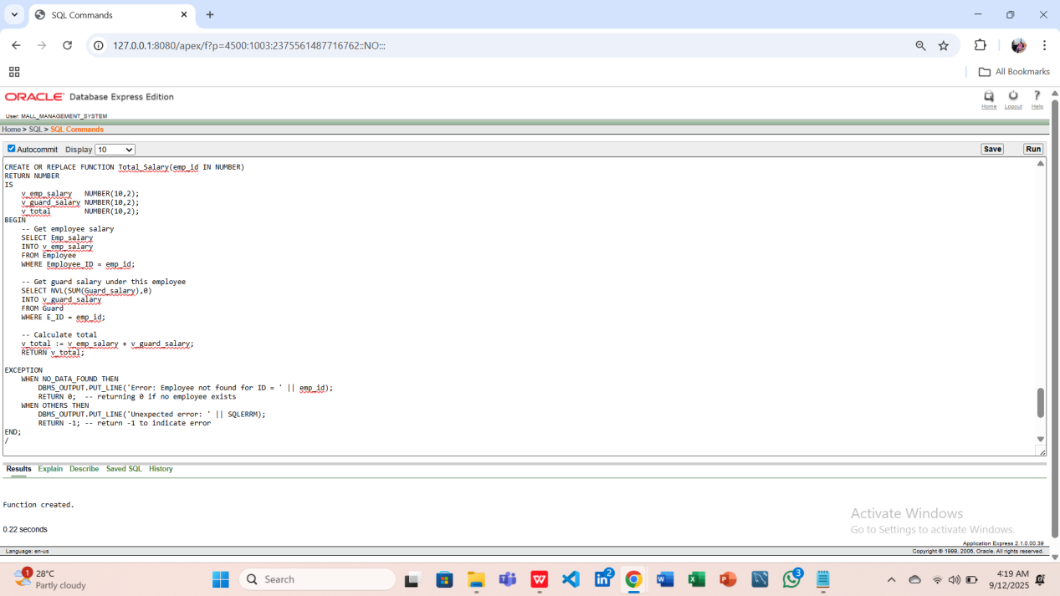

SELECT Total_Salary(301) AS total_salary FROM dual;

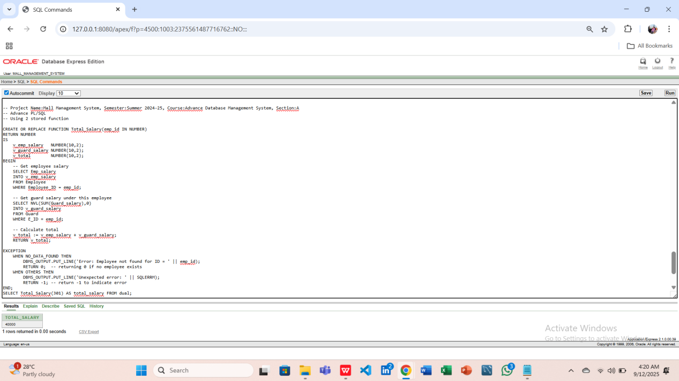

**Question-2: Write a stored function to calculate total payment made by a tenant.**

**Answer:**

CREATE OR REPLACE FUNCTION Tenant_Total_Payment(t_id IN NUMBER)

RETURN NUMBER

IS

v_total NUMBER(10,2);

BEGIN

-- Calculate total payments made by tenant

SELECT NVL(SUM(Amount),0)

INTO v_total

FROM Payment

WHERE T_ID = t_id;

RETURN v_total;

EXCEPTION

WHEN NO_DATA_FOUND THEN

DBMS_OUTPUT.PUT_LINE('Error: No payment records found for Tenant ID = ' || t_id);

RETURN 0; -- return 0 if no rows found

WHEN OTHERS THEN

DBMS_OUTPUT.PUT_LINE('Unexpected error: ' || SQLERRM);

RETURN -1; -- return -1 to indicate error

END;

SELECT Tenant_Total_Payment(501) AS total_payment

FROM dual;

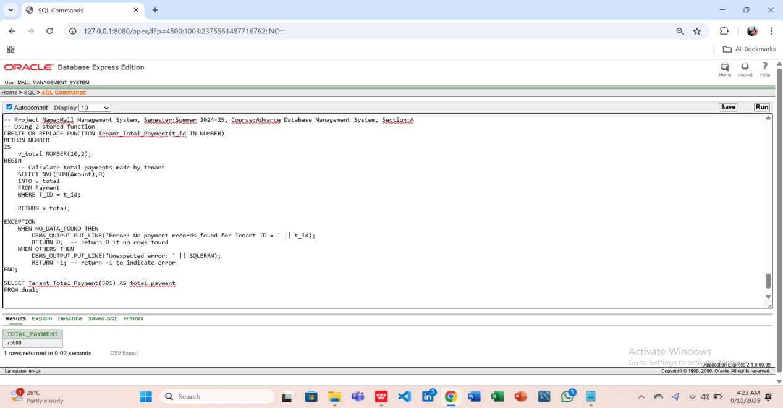

**-2 stored procedure**

**Question-1: Write a stored procedure to display all Shops and their Admin names.**

**Answer:**

CREATE OR REPLACE PROCEDURE Show_Shops_Admins

IS

BEGIN

-- Loop through all shops and their admins

FOR rec IN (SELECT S.Shop_name, A.Admin_name

FROM Shop S

JOIN Admin A ON S.A_ID = A.Admin_ID) LOOP

DBMS_OUTPUT.PUT_LINE('Shop: ' || rec.Shop_name || ' | Admin: ' || rec.Admin_name);

END LOOP;

EXCEPTION

WHEN NO_DATA_FOUND THEN

DBMS_OUTPUT.PUT_LINE('No shops or admins found.');

WHEN OTHERS THEN

DBMS_OUTPUT.PUT_LINE('Unexpected error: ' || SQLERRM);

END;

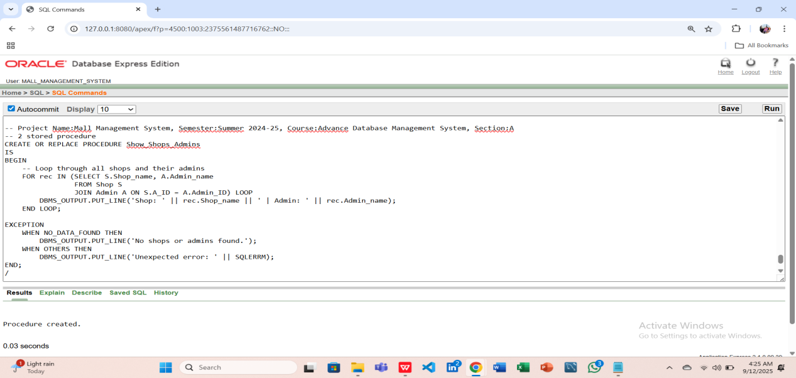

BEGIN

Show_Shops_Admins; -- Call the procedure

END;

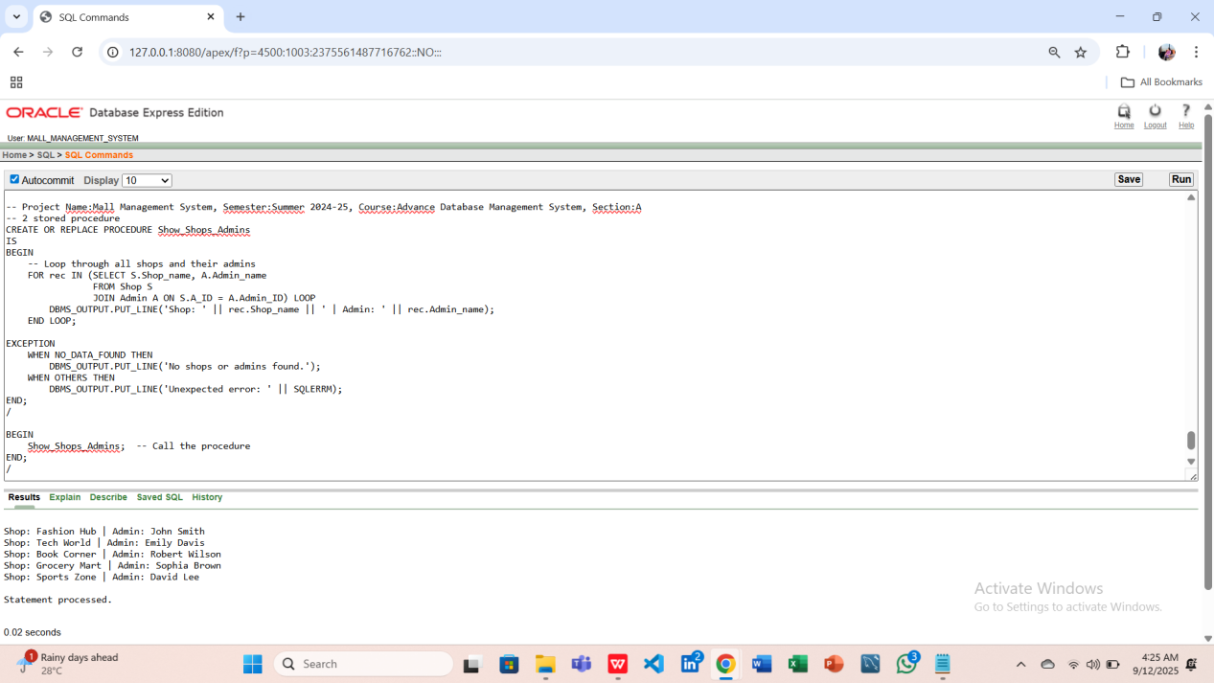

**Question-2: Write a stored procedure to display Employee and total Guard salary under them.**

**Answer:**

CREATE OR REPLACE PROCEDURE Show_Emp_Guard_Salary(emp_id IN NUMBER)

IS

v_total_salary NUMBER(10,2);

BEGIN

-- Call the Total_Salary function

v_total_salary := Total_Salary(emp_id);

DBMS_OUTPUT.PUT_LINE('Employee ID: ' || emp_id ||

' | Total Salary (including guards): ' || v_total_salary);

EXCEPTION

WHEN OTHERS THEN

DBMS_OUTPUT.PUT_LINE('Error calculating total salary for Employee ID ' || emp_id ||

': ' || SQLERRM);

END;

BEGIN

Show_Emp_Guard_Salary(301);

Show_Emp_Guard_Salary(302);

Show_Emp_Guard_Salary(303);

END;

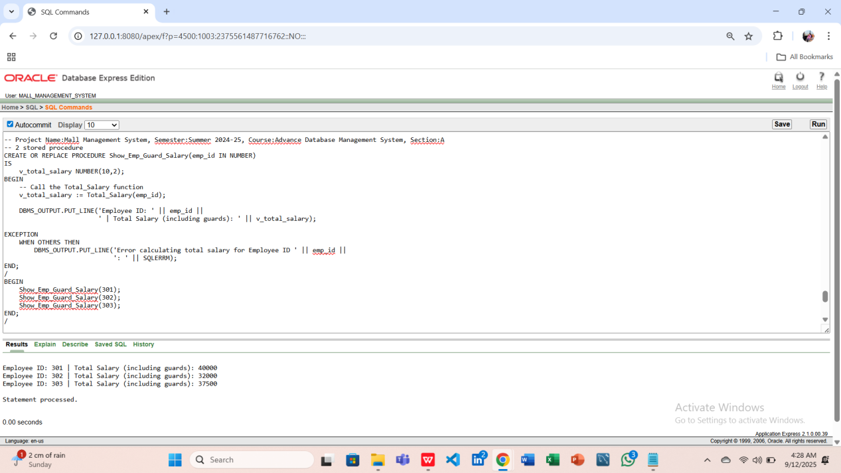

**-2 table-based record**

**Question-1:Display all Employees using a table-based record type.**

**Answer:**

DECLARE

TYPE emp_table_type IS TABLE OF Employee%ROWTYPE;

emp_table emp_table_type;

BEGIN

-- Fetch all employees into a collection

SELECT * BULK COLLECT INTO emp_table FROM Employee;

-- Loop through the collection

FOR i IN 1..emp_table.COUNT LOOP

DBMS_OUTPUT.PUT_LINE('Employee Name: ' || emp_table(i).Employee_name ||

' | Salary: ' || emp_table(i).Emp_salary);

END LOOP;

EXCEPTION

WHEN NO_DATA_FOUND THEN

DBMS_OUTPUT.PUT_LINE('No employees found.');

WHEN OTHERS THEN

DBMS_OUTPUT.PUT_LINE('Unexpected error: ' || SQLERRM);

END;

/

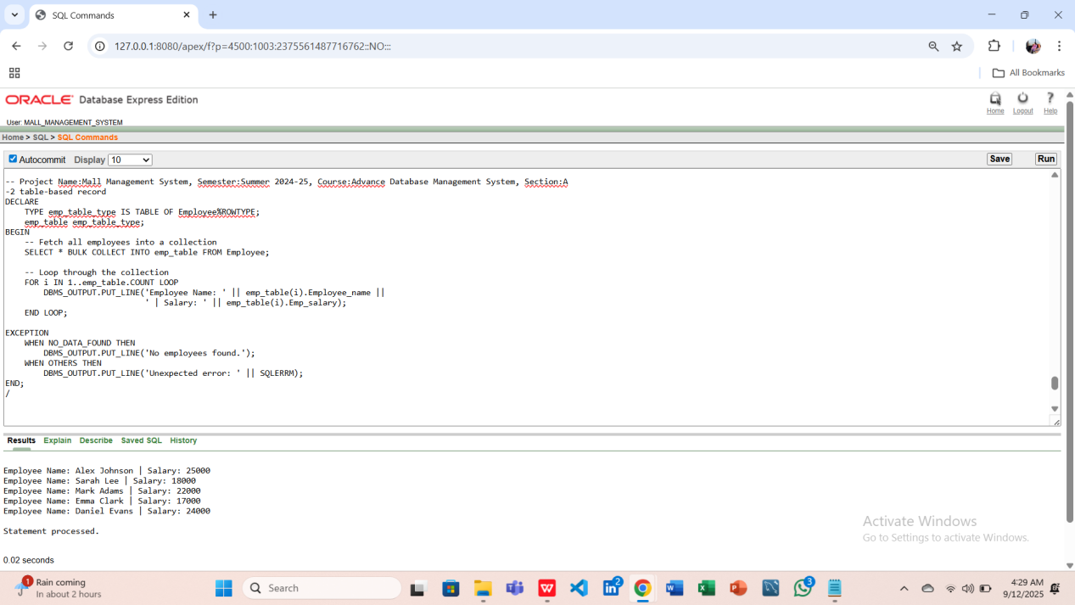

### ****Question 2:**** Display all Tenants using a table-based record type.

**Answer:**

DECLARE

TYPE tenant_table_type IS TABLE OF Tenant%ROWTYPE;

tenant_table tenant_table_type;

BEGIN

-- Fetch all tenants into a collection

SELECT * BULK COLLECT INTO tenant_table FROM Tenant;

-- Loop through the collection

FOR i IN 1..tenant_table.COUNT LOOP

DBMS_OUTPUT.PUT_LINE('Tenant Name: ' || tenant_table(i).Tenant_name ||

' | Email: ' || tenant_table(i).Tenant_email);

END LOOP;

EXCEPTION

WHEN NO_DATA_FOUND THEN

DBMS_OUTPUT.PUT_LINE('No tenants found.');

WHEN OTHERS THEN

DBMS_OUTPUT.PUT_LINE('Unexpected error: ' || SQLERRM);

END;

/

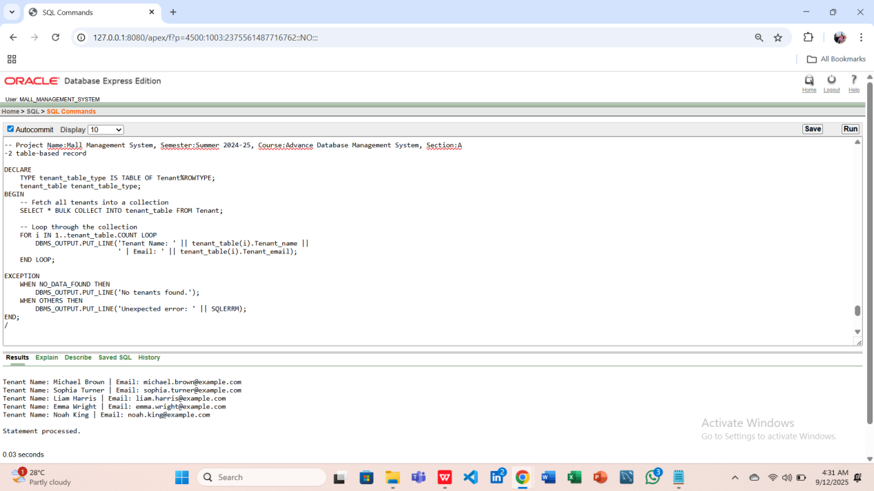

**-2 explicit cursor**

### ****Question 1:**** Display Shop names and types using an explicit cursor.

**Answer:**

DECLARE

CURSOR shop_cur IS SELECT Shop_name, Shop_type FROM Shop;

v_name Shop.Shop_name%TYPE;

v_type Shop.Shop_type%TYPE;

BEGIN

OPEN shop_cur;

LOOP

FETCH shop_cur INTO v_name, v_type;

EXIT WHEN shop_cur%NOTFOUND;

DBMS_OUTPUT.PUT_LINE('Shop: ' || v_name || ' | Type: ' || v_type);

END LOOP;

CLOSE shop_cur;

EXCEPTION

WHEN NO_DATA_FOUND THEN

DBMS_OUTPUT.PUT_LINE('No shops found.');

WHEN OTHERS THEN

DBMS_OUTPUT.PUT_LINE('Unexpected error: ' || SQLERRM);

-- Ensure cursor is closed if an exception occurs

IF shop_cur%ISOPEN THEN

CLOSE shop_cur;

END IF;

END;

/

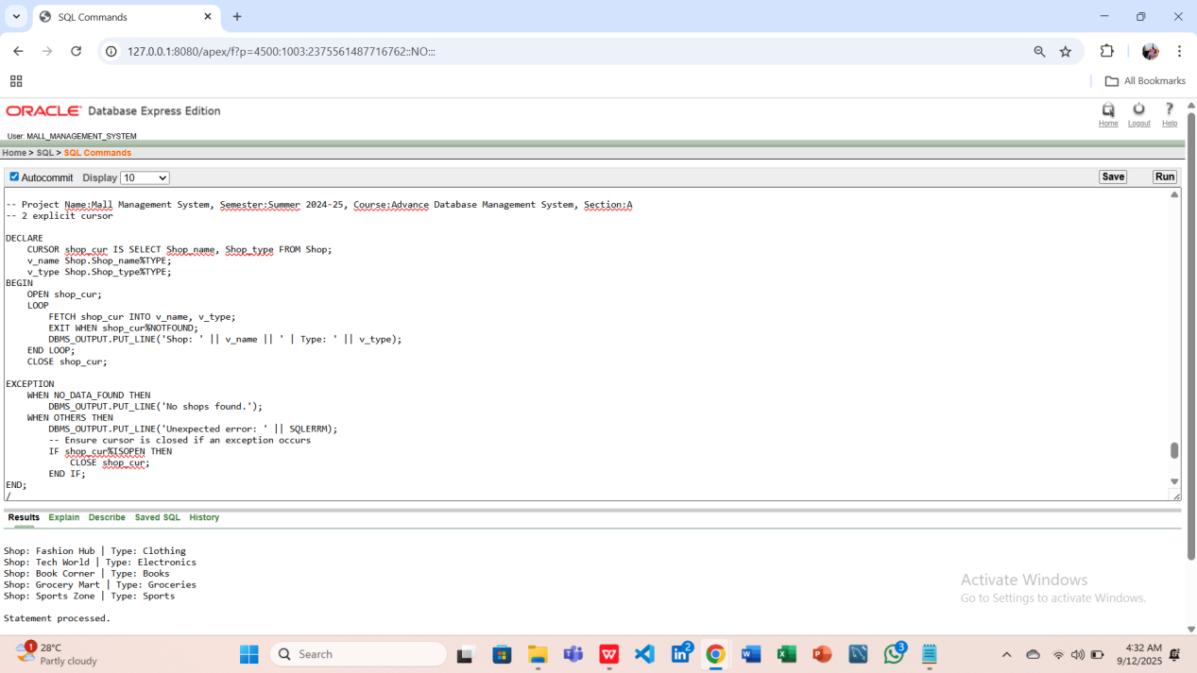

**Question -2: Display Customer names and their Shop names using an explicit cursor.**

**Answer:**

DECLARE

CURSOR cust_cur IS

SELECT C.Customer_name, S.Shop_name

FROM Customer C

JOIN Shop S ON C.S_ID = S.Shop_ID;

v_cust Customer.Customer_name%TYPE;

v_shop Shop.Shop_name%TYPE;

BEGIN

OPEN cust_cur;

LOOP

FETCH cust_cur INTO v_cust, v_shop;

EXIT WHEN cust_cur%NOTFOUND;

DBMS_OUTPUT.PUT_LINE('Customer: ' || v_cust || ' | Shop: ' || v_shop);

END LOOP;

CLOSE cust_cur;

EXCEPTION

WHEN NO_DATA_FOUND THEN

DBMS_OUTPUT.PUT_LINE('No customers or shops found.');

WHEN OTHERS THEN

DBMS_OUTPUT.PUT_LINE('Unexpected error: ' || SQLERRM);

-- Ensure cursor is closed if an exception occurs

IF cust_cur%ISOPEN THEN

CLOSE cust_cur;

END IF;

END;

/

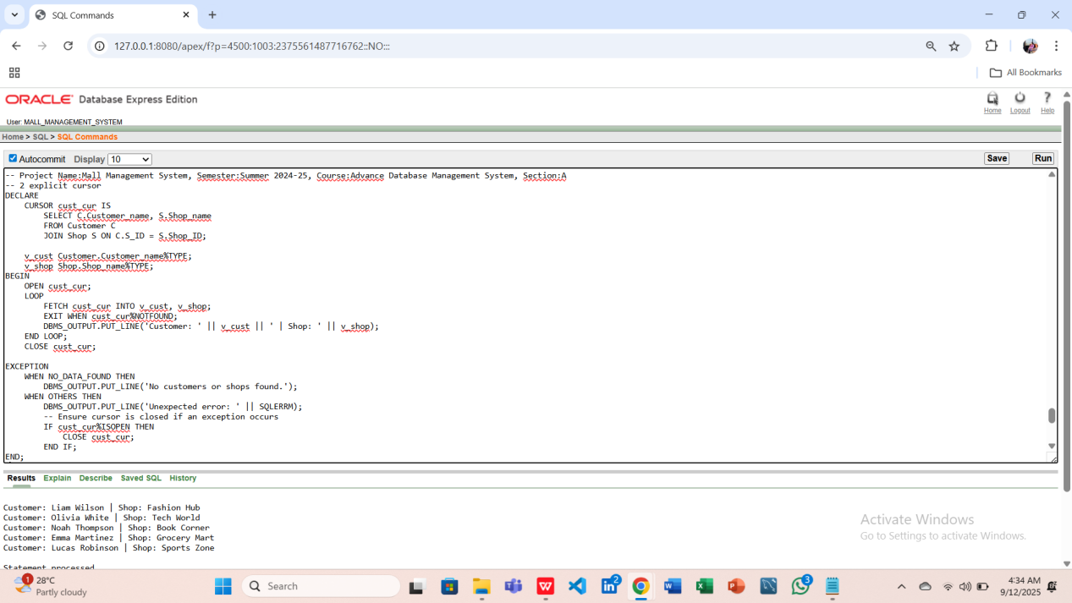

**-2 cursor-based record**

### ****Question 1:****Display Employee and salary using a cursor-based record.

**Answer:**

DECLARE

CURSOR emp_cur IS

SELECT Employee_name, Emp_salary FROM Employee;

emp_rec emp_cur%ROWTYPE;

BEGIN

OPEN emp_cur;

LOOP

FETCH emp_cur INTO emp_rec;

EXIT WHEN emp_cur%NOTFOUND;

DBMS_OUTPUT.PUT_LINE('Employee: ' || emp_rec.Employee_name || ' | Salary: ' || emp_rec.Emp_salary);

END LOOP;

CLOSE emp_cur;

EXCEPTION

WHEN NO_DATA_FOUND THEN

DBMS_OUTPUT.PUT_LINE('No employees found.');

WHEN OTHERS THEN

DBMS_OUTPUT.PUT_LINE('Unexpected error: ' || SQLERRM);

-- Ensure cursor is closed if an exception occurs

IF emp_cur%ISOPEN THEN

CLOSE emp_cur;

END IF;

END;

/

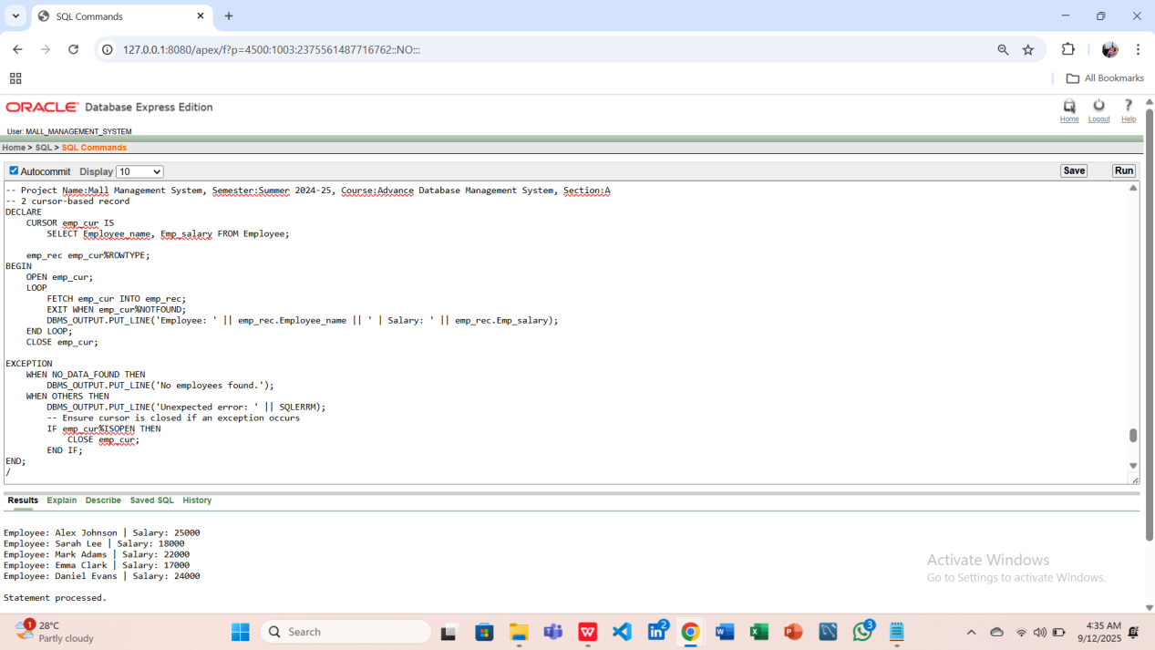

**Question-2:Display Guards and their shift times using a cursor-based record.**

**Answer:**

DECLARE

CURSOR guard_cur IS

SELECT Guard_name, Guard_shift_time FROM Guard;

guard_rec guard_cur%ROWTYPE;

BEGIN

OPEN guard_cur;

LOOP

FETCH guard_cur INTO guard_rec;

EXIT WHEN guard_cur%NOTFOUND;

DBMS_OUTPUT.PUT_LINE('Guard: ' || guard_rec.Guard_name || ' | Shift: ' || guard_rec.Guard_shift_time);

END LOOP;

CLOSE guard_cur;

EXCEPTION

WHEN NO_DATA_FOUND THEN

DBMS_OUTPUT.PUT_LINE('No guards found.');

WHEN OTHERS THEN

DBMS_OUTPUT.PUT_LINE('Unexpected error: ' || SQLERRM);

-- Ensure cursor is closed if an exception occurs

IF guard_cur%ISOPEN THEN

CLOSE guard_cur;

END IF;

END;

/

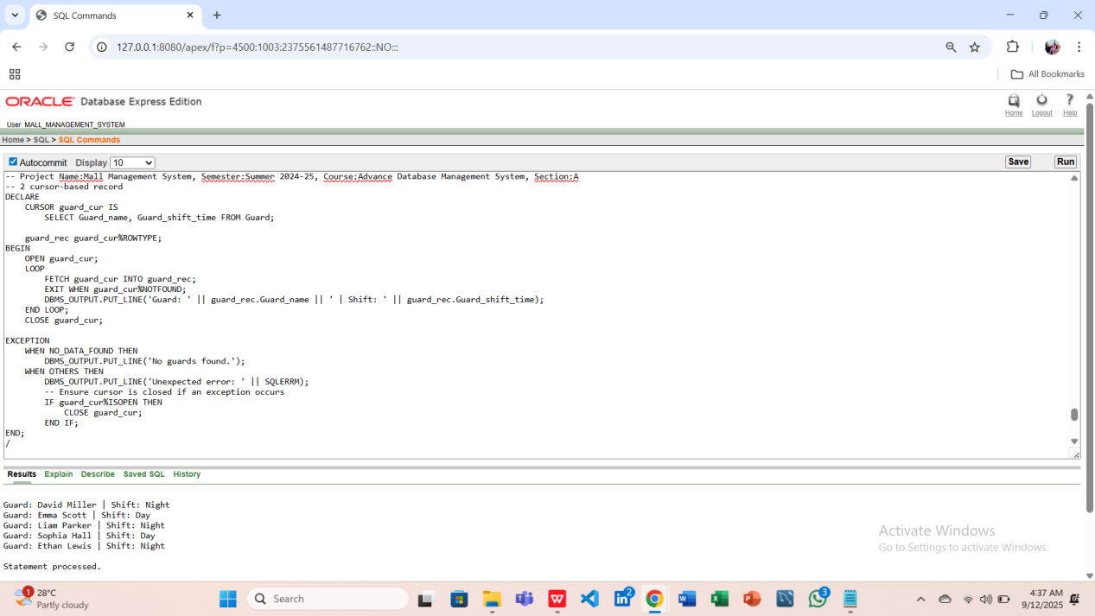

**-2 row level trigger**

### ****Question-1:**** Create a row-level trigger to log ****any insert in Payment table****.

**Answer:**

CREATE OR REPLACE TRIGGER log_payment_insert

AFTER INSERT ON Payment

FOR EACH ROW

BEGIN

BEGIN

DBMS_OUTPUT.PUT_LINE('New Payment Inserted: Payment_ID = ' || :NEW.Payment_ID ||

', Amount = ' || :NEW.Amount);

EXCEPTION

WHEN OTHERS THEN

DBMS_OUTPUT.PUT_LINE('Error in log_payment_insert trigger: ' || SQLERRM);

END;

END;

/

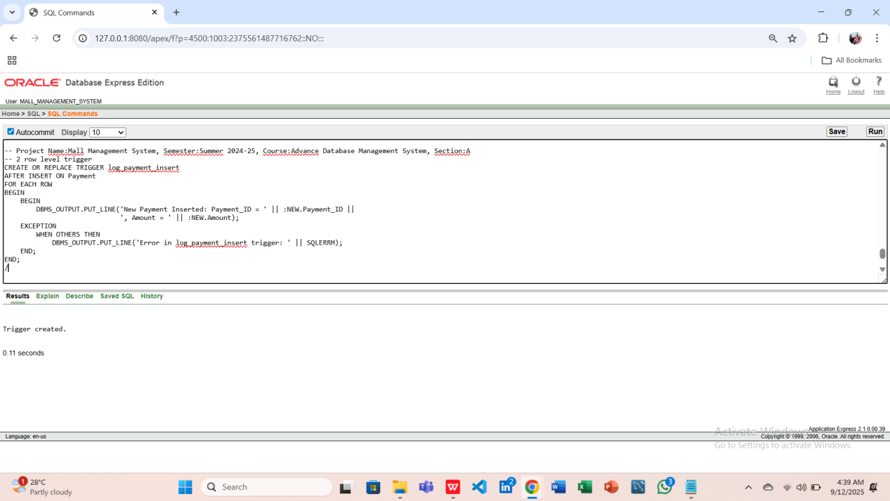

-- Insert a Test Payment

INSERT INTO Payment (Payment_ID, Amount, Payment_date, Payment_method, T_ID)

VALUES (606, 17000, TO_DATE('2025-08-06','YYYY-MM-DD'), 'Card', 501);

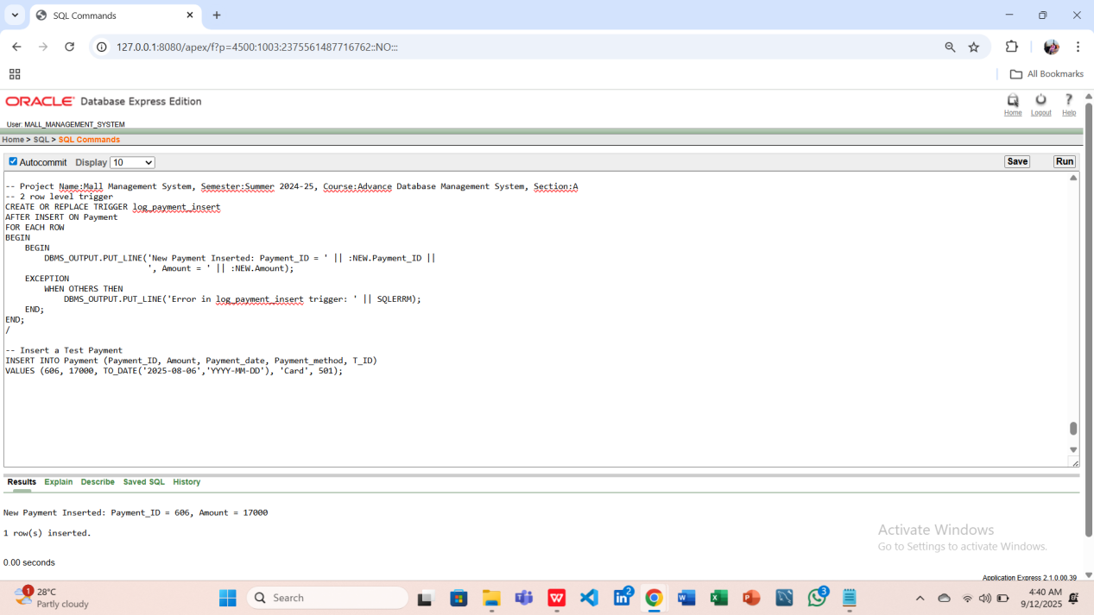

-- Verifying if the Row is in Table

SELECT * FROM Payment WHERE Payment_ID = 606;

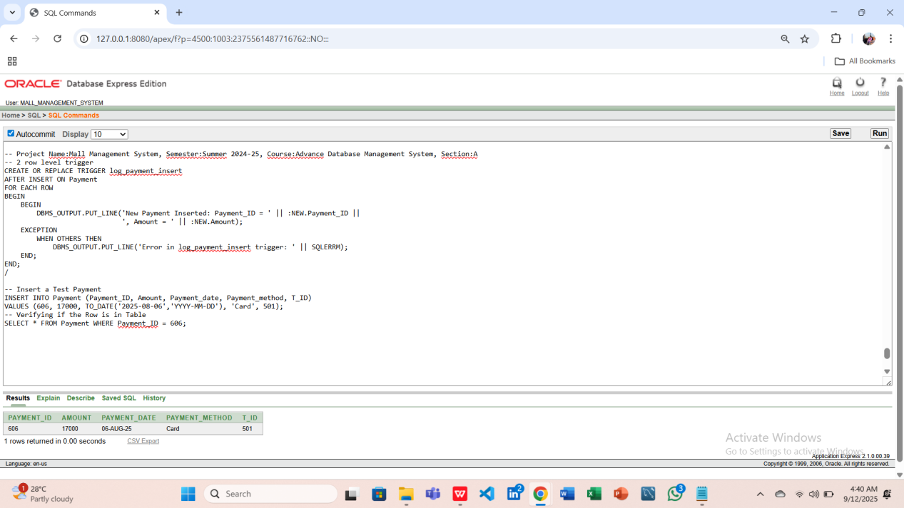

-- Cleanup (optional, after testing just cleaned that unnecessary row)

DELETE FROM Payment WHERE Payment_ID = 606;

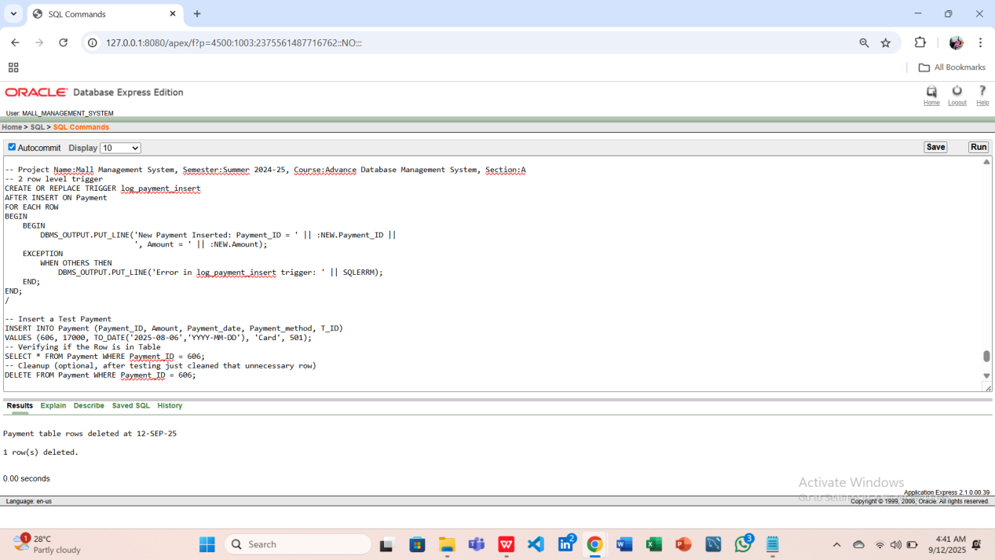

### ****Question-2:**** Create a row-level trigger to ****log new Customer insertion****.

**Answer:**

CREATE OR REPLACE TRIGGER log_customer_insert

AFTER INSERT ON Customer

FOR EACH ROW

BEGIN

BEGIN

DBMS_OUTPUT.PUT_LINE('New Customer: ' || :NEW.Customer_name ||

' | Shop ID: ' || :NEW.S_ID);

EXCEPTION

WHEN OTHERS THEN

DBMS_OUTPUT.PUT_LINE('Error in log_customer_insert trigger: ' || SQLERRM);

END;

END;

/

-- Insert a Test Customer

INSERT INTO Customer (Customer_ID, Customer_name, Customer_email, Customer_phone, Visit_date, Feedback, S_ID)

VALUES (806, 'Sophia Green', 'sophia.green@example.com', '01710000036', TO_DATE('2025-08-06','YYYY-MM-DD'), 'Excellent service', 102);

-- Verifying the Row is Inserted

SELECT * FROM Customer WHERE Customer_ID = 806;

-- Cleanup (optional, after testing just cleaned that unnecessary row)

DELETE FROM Customer WHERE Customer_ID = 806;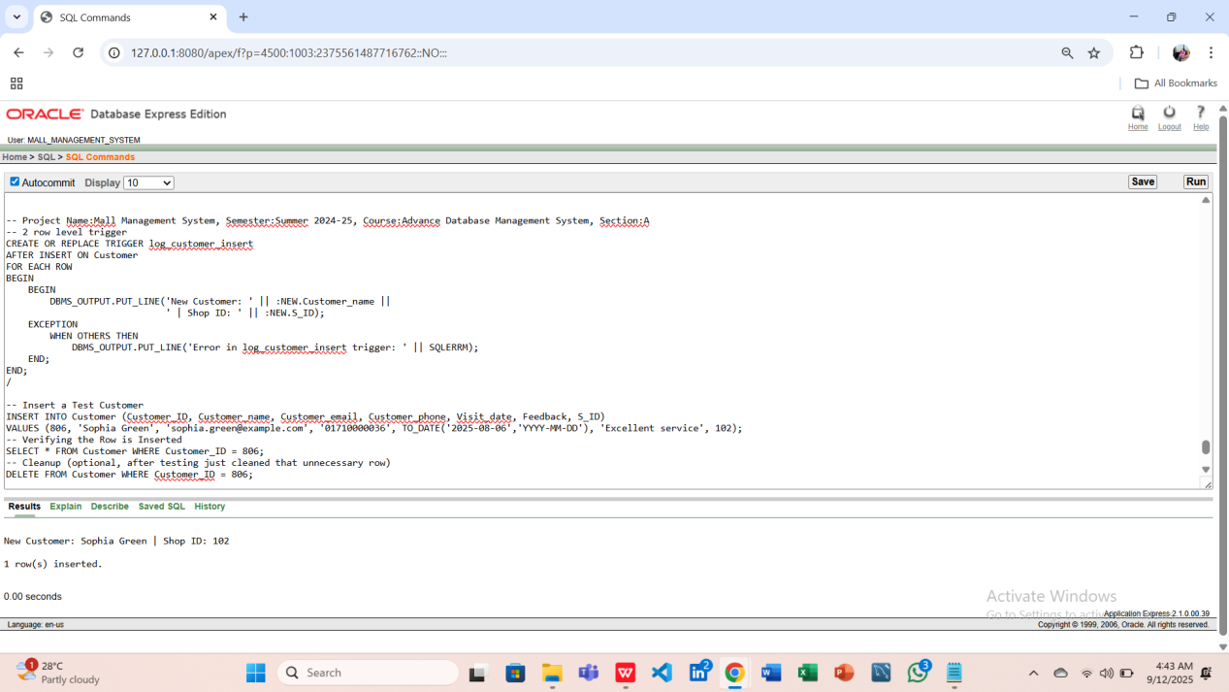

**-2 statement level trigger**

### ****Question-1:**** Create a statement-level trigger to log ****any update in Shop table****.

**Answer:**

CREATE OR REPLACE TRIGGER log_shop_update

AFTER UPDATE ON Shop

BEGIN

BEGIN

DBMS_OUTPUT.PUT_LINE('Shop table updated at ' || SYSDATE);

EXCEPTION

WHEN OTHERS THEN

DBMS_OUTPUT.PUT_LINE('Error in log_shop_update trigger: ' || SQLERRM);

END;

END;

/

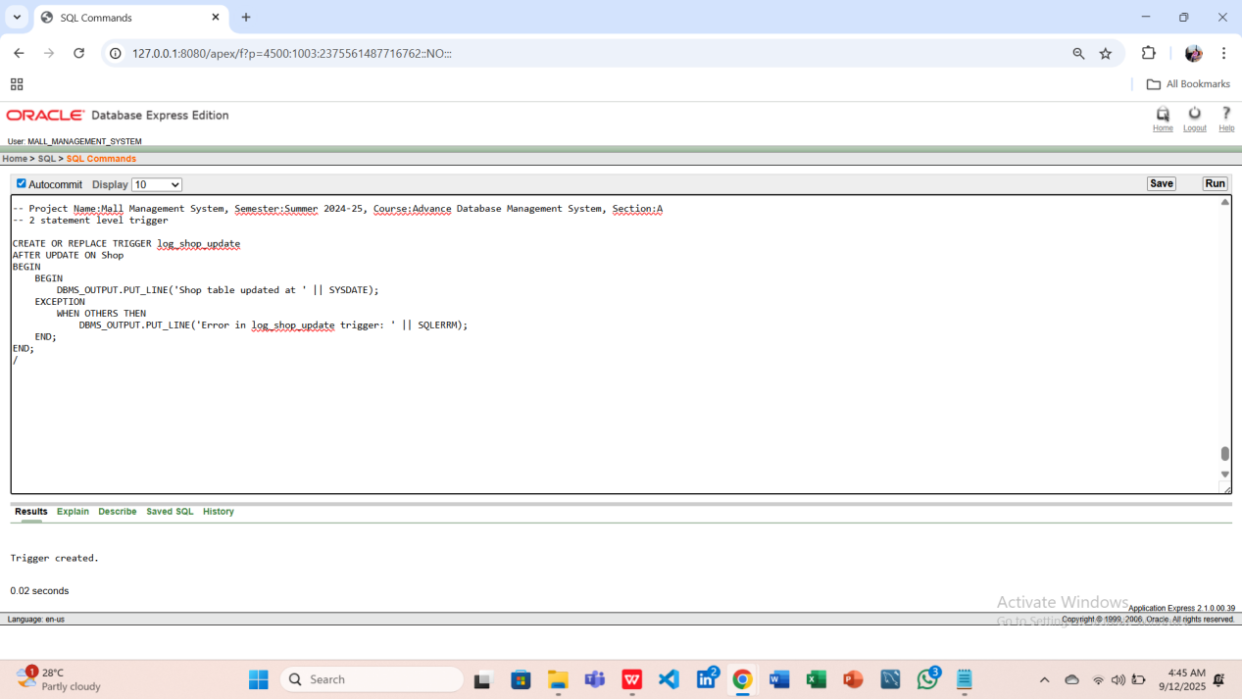

-- Testing log_shop_update Trigger

UPDATE Shop

SET Shop_status = 'Closed'

WHERE Shop_ID = 101;

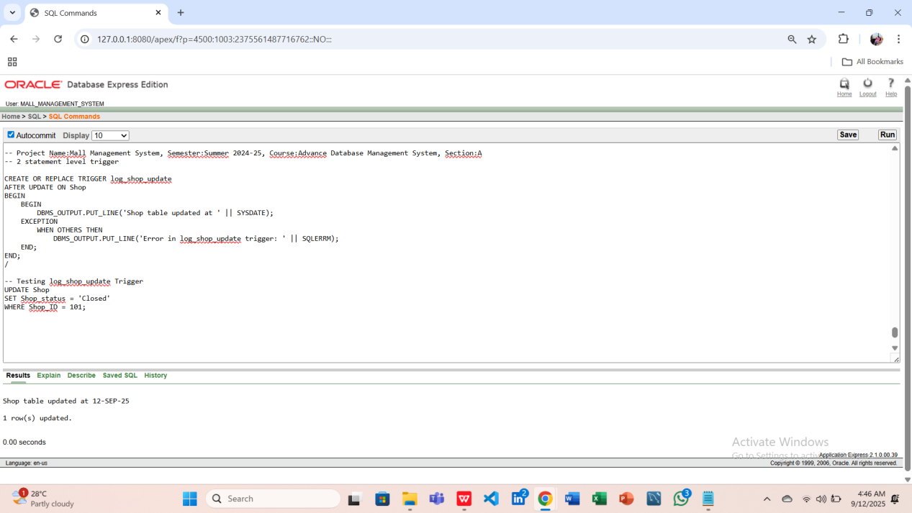

-- Reverted the previous value

UPDATE Shop

SET Shop_status = 'Open'

WHERE Shop_ID = 101;

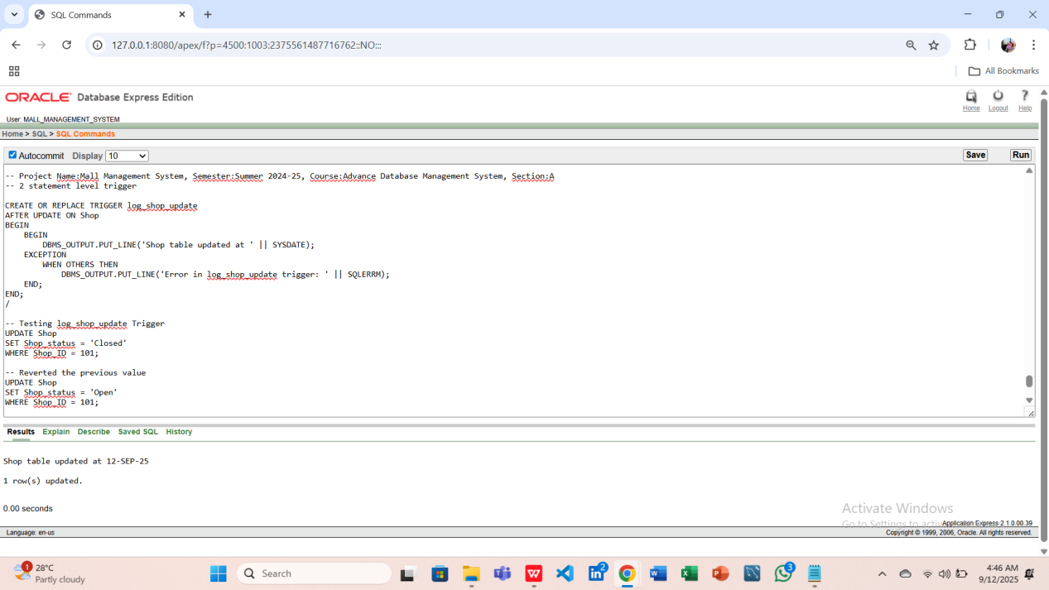

### ****Question-2:**** Create a statement-level trigger to log ****any delete from Payment table****.

**Answer:**

CREATE OR REPLACE TRIGGER log_payment_delete

AFTER DELETE ON Payment

BEGIN

BEGIN

DBMS_OUTPUT.PUT_LINE('Payment table rows deleted at ' || SYSDATE);

EXCEPTION

WHEN OTHERS THEN

DBMS_OUTPUT.PUT_LINE('Error in log_payment_delete trigger: ' || SQLERRM);

END;

END;

/-- Testing the Trigger, Inserting a sample row

INSERT INTO Payment (Payment_ID, Amount, Payment_date, Payment_method, T_ID)

VALUES (606, 17000, TO_DATE('2025-08-06','YYYY-MM-DD'), 'Card', 501);

-- Performing the Triggering Action

DELETE FROM Payment

WHERE Payment_ID = 606;

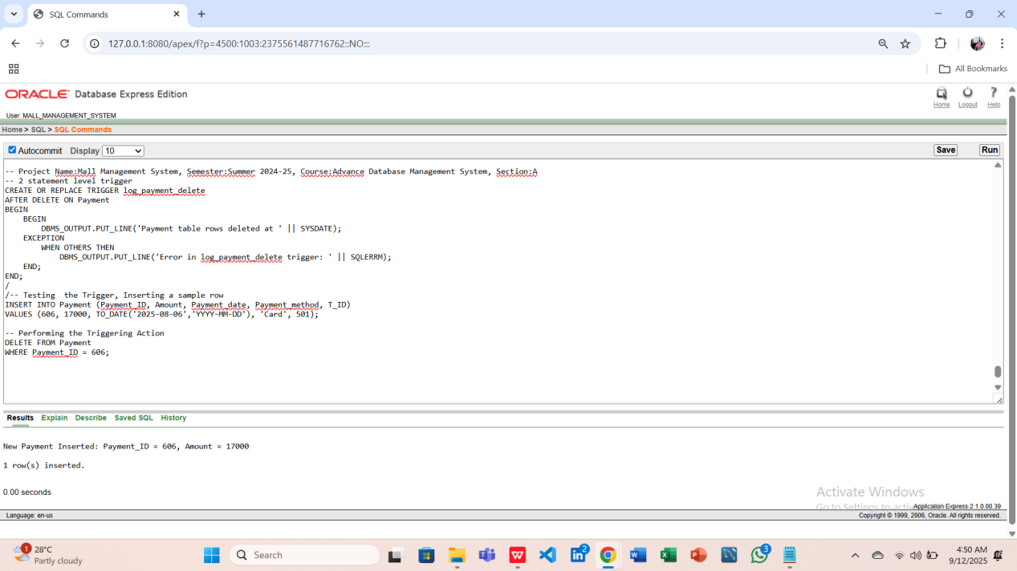

**-2 package**

### ****Question-1:****Create a package to handle Employee salary queries.

**Answer:**

-- Package Specification

CREATE OR REPLACE PACKAGE emp_pkg IS

FUNCTION Get_Total_Salary(emp_id IN NUMBER) RETURN NUMBER;

PROCEDURE Show_Employee(emp_id IN NUMBER);

END emp_pkg;

/

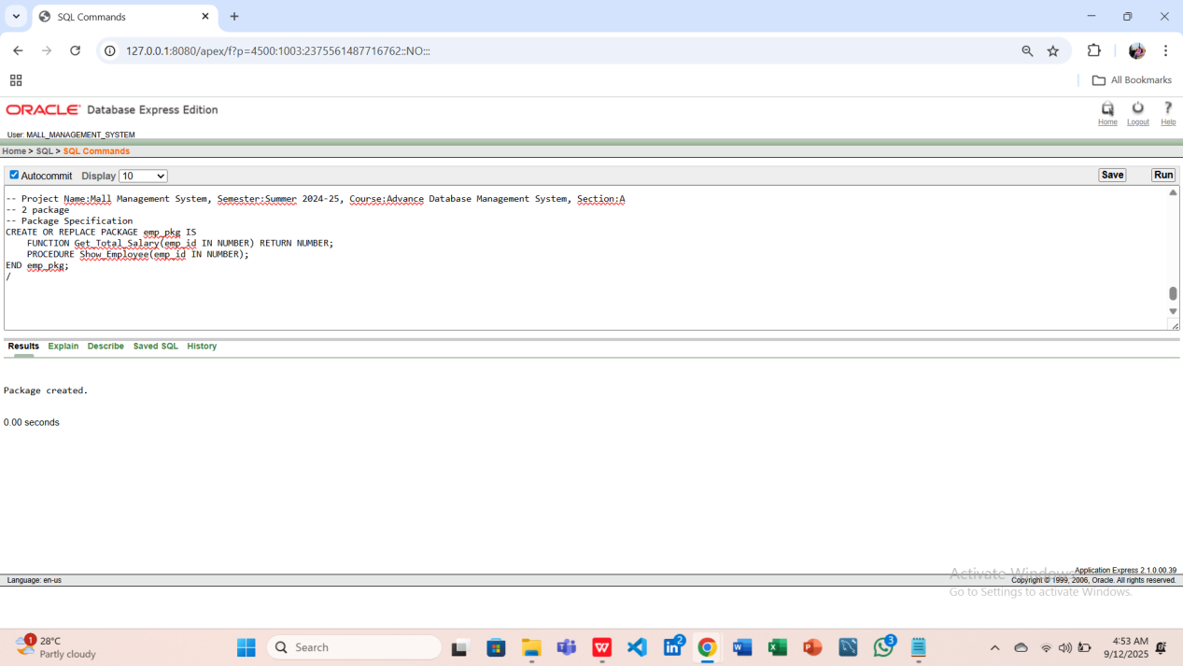

-- Package Body

CREATE OR REPLACE PACKAGE BODY emp_pkg IS

-- Function to get total salary

FUNCTION Get_Total_Salary(emp_id IN NUMBER) RETURN NUMBER IS

v_salary NUMBER(10,2);

BEGIN

SELECT Emp_salary INTO v_salary

FROM Employee

WHERE Employee_ID = emp_id;

RETURN v_salary;

EXCEPTION

WHEN NO_DATA_FOUND THEN

DBMS_OUTPUT.PUT_LINE('Employee not found for ID = ' || emp_id);

RETURN 0;

WHEN OTHERS THEN

DBMS_OUTPUT.PUT_LINE('Unexpected error in Get_Total_Salary: ' || SQLERRM);

RETURN -1;

END Get_Total_Salary;

-- Procedure to display employee info

PROCEDURE Show_Employee(emp_id IN NUMBER) IS

v_name Employee.Employee_name%TYPE;

v_salary NUMBER(10,2);

BEGIN

SELECT Employee_name, Emp_salary INTO v_name, v_salary

FROM Employee

WHERE Employee_ID = emp_id;

DBMS_OUTPUT.PUT_LINE('Employee: ' || v_name || ' | Salary: ' || v_salary);

EXCEPTION

WHEN NO_DATA_FOUND THEN

DBMS_OUTPUT.PUT_LINE('Employee not found for ID = ' || emp_id);

WHEN OTHERS THEN

DBMS_OUTPUT.PUT_LINE('Unexpected error in Show_Employee: ' || SQLERRM);

END Show_Employee;

END emp_pkg;

/

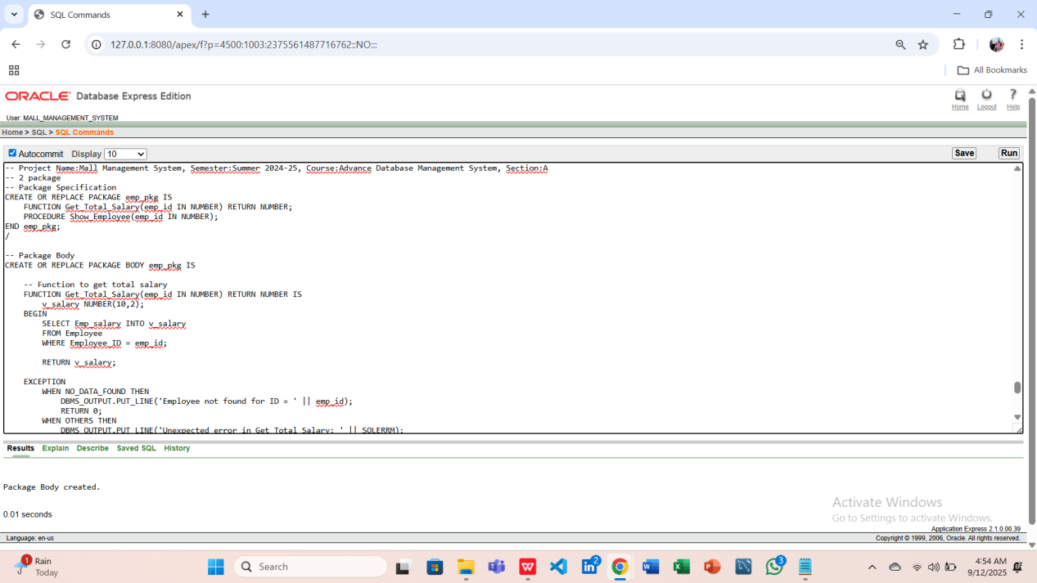

-- Checking package objects

SELECT object_name, object_type, status

FROM user_objects

WHERE object_name = 'EMP_PKG';

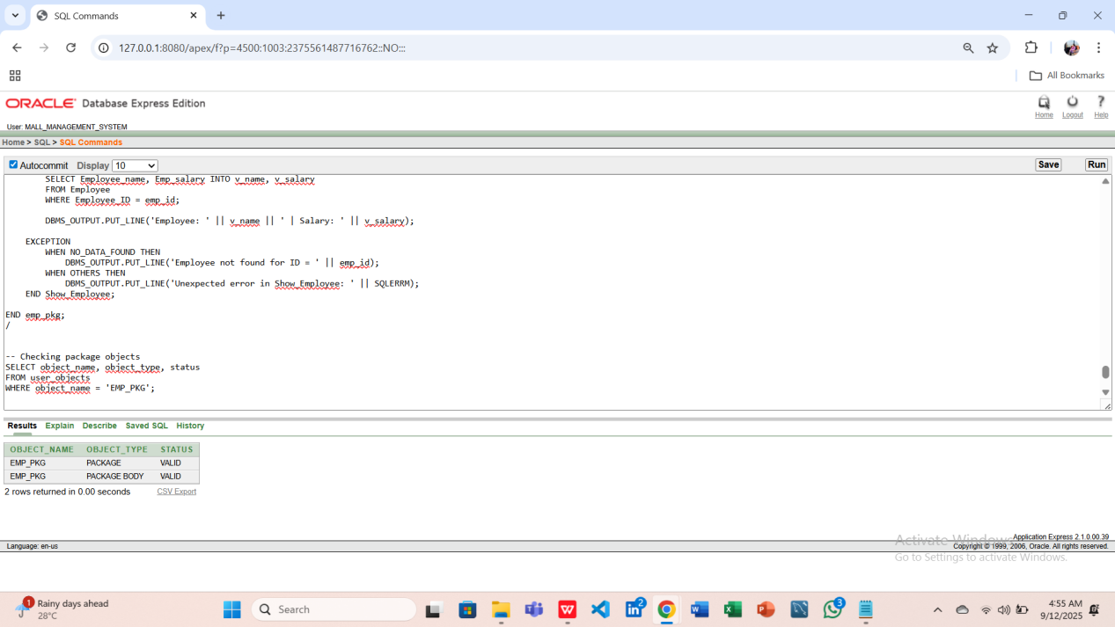

### ****Question-2:****Create a package to handle Tenant payment queries.

**Answer:**

-- Package Specification

CREATE OR REPLACE PACKAGE tenant_pkg IS

FUNCTION Total_Payment(t_id IN NUMBER) RETURN NUMBER;

PROCEDURE Show_Tenant(t_id IN NUMBER);

END tenant_pkg;

/

-- Package Body

CREATE OR REPLACE PACKAGE BODY tenant_pkg IS

-- Function to calculate total payment

FUNCTION Total_Payment(t_id IN NUMBER) RETURN NUMBER IS

v_total NUMBER(10,2);

BEGIN

SELECT NVL(SUM(Amount),0) INTO v_total

FROM Payment

WHERE T_ID = t_id;

RETURN v_total;

EXCEPTION

WHEN NO_DATA_FOUND THEN

DBMS_OUTPUT.PUT_LINE('No payments found for Tenant ID = ' || t_id);

RETURN 0;

WHEN OTHERS THEN

DBMS_OUTPUT.PUT_LINE('Unexpected error in Total_Payment: ' || SQLERRM);

RETURN -1;

END Total_Payment;

-- Procedure to show tenant details

PROCEDURE Show_Tenant(t_id IN NUMBER) IS

v_name Tenant.Tenant_name%TYPE;

v_total NUMBER(10,2);

BEGIN

SELECT Tenant_name INTO v_name

FROM Tenant

WHERE Tenant_ID = t_id;

v_total := Total_Payment(t_id);

DBMS_OUTPUT.PUT_LINE('Tenant: ' || v_name || ' | Total Payment: ' || v_total);

EXCEPTION

WHEN NO_DATA_FOUND THEN

DBMS_OUTPUT.PUT_LINE('Tenant not found for ID = ' || t_id);

WHEN OTHERS THEN

DBMS_OUTPUT.PUT_LINE('Unexpected error in Show_Tenant: ' || SQLERRM);

END Show_Tenant;

END tenant_pkg;

/

-- Checking package objects

SELECT object_name, object_type, status

FROM user_objects

WHERE object_name = 'TENANT_PKG';

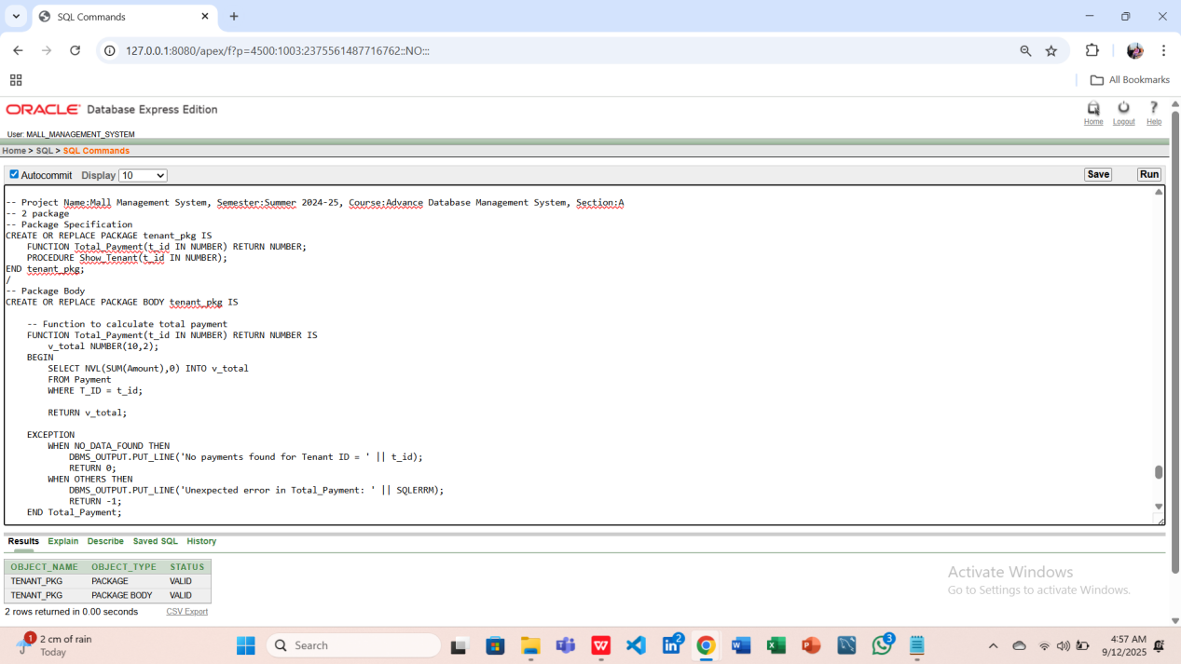

1. **Relational Algebra**

**Question 1: List the names and salaries of all Employees.**

**Answer :**   **π**Employee_name,Emp_salary(Employee)

**Question 2: Find the Guard working under Employee_ID = 301.**

**Answer :**  **π**Guard_name(σE_ID=301​(Guard))

**Question 3: List all Shops and the name of the Admin managing them.**

**Answer : π**Shop_name,Admin_name(Shop**⋈**Shop.A_ID=Admin.Admin_ID​Admin)

**Question 4: Find the total payment made by Tenant_ID = 501.**

**Answer :**  **γ**SUM(Amount)→Total_Payment(σT_ID=501​(Payment))

**Question 5: List all Tenants who have made payments greater than 15000.**

**Answer : π**Tenant_name(σAmount>15000(Payment**⋈**Payment.T_ID=Tenant.Tenant_ID​

Tenant))

1. **User Interface Design To Code Implementation (Screenshots)**
2. **Oracle 10g Database Connection Process**

Based on the midterm UI designs, we implemented the corresponding user interfaces in **C# programming language**.

The following procedure was followed to connect Oracle 10g Database using C# programming language:

**1. Oracle 10g Installation and Configuration**

First, we ensured that Oracle 10g Database was properly installed and running (It was already ensured in mid-term, as we created database & also table creation, data insertion were done). We checked the listener service and noted the host name, port number (default 1521), and database SID which would be required for the connection.

**2. Preparing the Development Environment**

Next, we prepared the development environment in Visual Studio. A new C# Console Application project was created where we would implement the connection code.

**3. Adding Oracle Data Access Library**

After creating the project, we added the required Oracle Data Access library. For this, the **Oracle.ManagedDataAccess.dll** file was included in the project references. This library is necessary for establishing communication between the C# application and the Oracle database.

**4. Constructing the Connection String**

Then we constructed the database connection string. In the connection string, we specified the database username, password, and the data source, which contained the host, port, and Oracle SID.

Example Format:  
User Id=**MALL_MANGEMENT_SYSTEM**; Password=**mall**; Data Source=localhost:1521/orcl;

**5. Writing the Connection Code**

After preparing the connection string, we wrote C# code to connect with the Oracle 10g database. Inside the code, we created an OracleConnection object using the connection string and opened the connection inside a try-catch block to handle any possible errors.

**6. Executing a Sample SQL Query**

Once the connection was successful, we executed a sample SQL query. For verification, a simple query was executed on the Oracle system table dual to fetch the current system date. The returned result confirmed that the connection was working correctly.

**7. Testing the Process**

Finally, we tested the entire process. The project was built and executed. On successful execution, a confirmation message displayed that the application was connected to the Oracle 10g database along with the current database date.

**8. Troubleshooting and Error Handling**

In case of errors, we reviewed common issues. For example, if the Oracle listener was not running, we started it using the Oracle tools. If the credentials were incorrect, we corrected them in the connection string. If the Oracle assembly was not found, we ensured that the Oracle Data Provider for .NET was properly installed.

This way, we successfully connected a C# application with the Oracle 10g Database and verified the connection by executing a query.

**Issues Faced During Oracle 10g Database Connection**

**Listener Not Running :** Sometimes the Oracle listener service was not active, which caused connection failures. We had to manually start it using Oracle tools.

**Invalid Credentials :** Connection attempts failed when incorrect usernames or passwords were entered. Updating the connection string with correct credentials solved this.

**Missing Oracle Assembly :** The project could not run if the Oracle Data Access library (Oracle.ManagedDataAccess.dll or Oracle.DataAccess.dll) was not properly installed or referenced.

**Port or Network Issues:** The default Oracle port (1521) was sometimes blocked by firewall or network restrictions, which prevented the C# application from connecting.

**Configuration Mismatches :** If the SID or service name in the connection string did not match the Oracle database configuration, the connection could not be established.

**Outdated Oracle 10g Version :** Since Oracle 10g is an older version, compatibility issues were faced with newer development tools and drivers. Some modern libraries do not fully support Oracle 10g, which required extra configuration and adjustments.

1. **Conclusion**

The Mall Management System successfully demonstrates how database-driven applications can streamline and organize mall operations. By integrating core functions such as shop and tenant management, customer tracking, inventory monitoring, billing, employee supervision, and facility maintenance, the system reduces manual errors, enhances efficiency, and ensures secure and consistent data handling. The use of proper database design principles, normalization, and PL/SQL queries ensures data integrity and reliability, while the centralized system provides quick access to information, supporting effective decision-making for mall administrators and shopkeepers. Overall, the project highlights the potential of database systems to improve real-world operations by saving time, minimizing errors, and providing structured insights.

**Future Work**

Although the system meets its primary objectives, there are several areas where it can be improved and expanded in the future:

1. **Web-Based User Interface** – Develop a web or mobile application connected to the database to allow mall staff, tenants, and customers to interact with the system in real time.

2. **Automation & Notifications** – Add features such as automated reminders for rent payments, stock replenishment alerts, and maintenance scheduling.

3. **Analytics & Reporting** – Integrate advanced reporting dashboards and data visualization tools for sales forecasting, customer trends, and performance analysis.

4. **Security Enhancements** – Implement stronger authentication, role-based access control, and encryption to protect sensitive tenant and customer data.

5. **Integration with IoT Devices** – Connect the system with sensors (e.g., for energy monitoring, security cameras, or foot traffic tracking) to enable smart mall management.

6. **Scalability Improvements** – Optimize the database for handling larger malls with thousands of shops, tenants, and customers without performance issues.

7. **Cloud Deployment** – Move the system to a cloud-based environment for better accessibility, reliability, and scalability.

By addressing these improvements, the Mall Management System can evolve into a fully functional, intelligent, and scalable solution capable of meeting the growing demands of modern shopping complexes.